**MACHINE LEARNING**

**HW4: VISUAL QUESTION ANSWERING**

**Group Member Names**

Rashik Reddy Gurrala - 1002031534

Saketh Bandaru - 1002026743

Venkata Sainath Reddy Palavala - 1001949223

Natraj Hullikunte - 1001912794

Note: Code Ran and Viewed on Jupyter-notebook

# Visual Question Answering with Keras

We can define, “Visual Question Answering (VQA) is a system that takes an image and natural language question about the image as an input and generates natural language answer as an output.”

VQA is a research area that requires an understanding of vision (Computer Vision) as well as text (NLP).

The main beauty of VQA is that the reasoning part is performed in the context of the image.

So, if we have an image with the corresponding question then the system must able to understand the image well in order to generate an appropriate answer.

place the coco folder into data/ folder

download the raw images from here: http://mscoco.org/

and place them all into coco/train2014 and coco/val2014 .

You must do this if you wish to visualize the predictions

Initially You need to download questions and annotation files from website visual.org

2. mscoco contain open ended questions ,Annotations and images

3. train_mscoco contain train question json

4.val_mscoco contain val questions and images json

2. These files we used in pre-processing code to generate a txt file

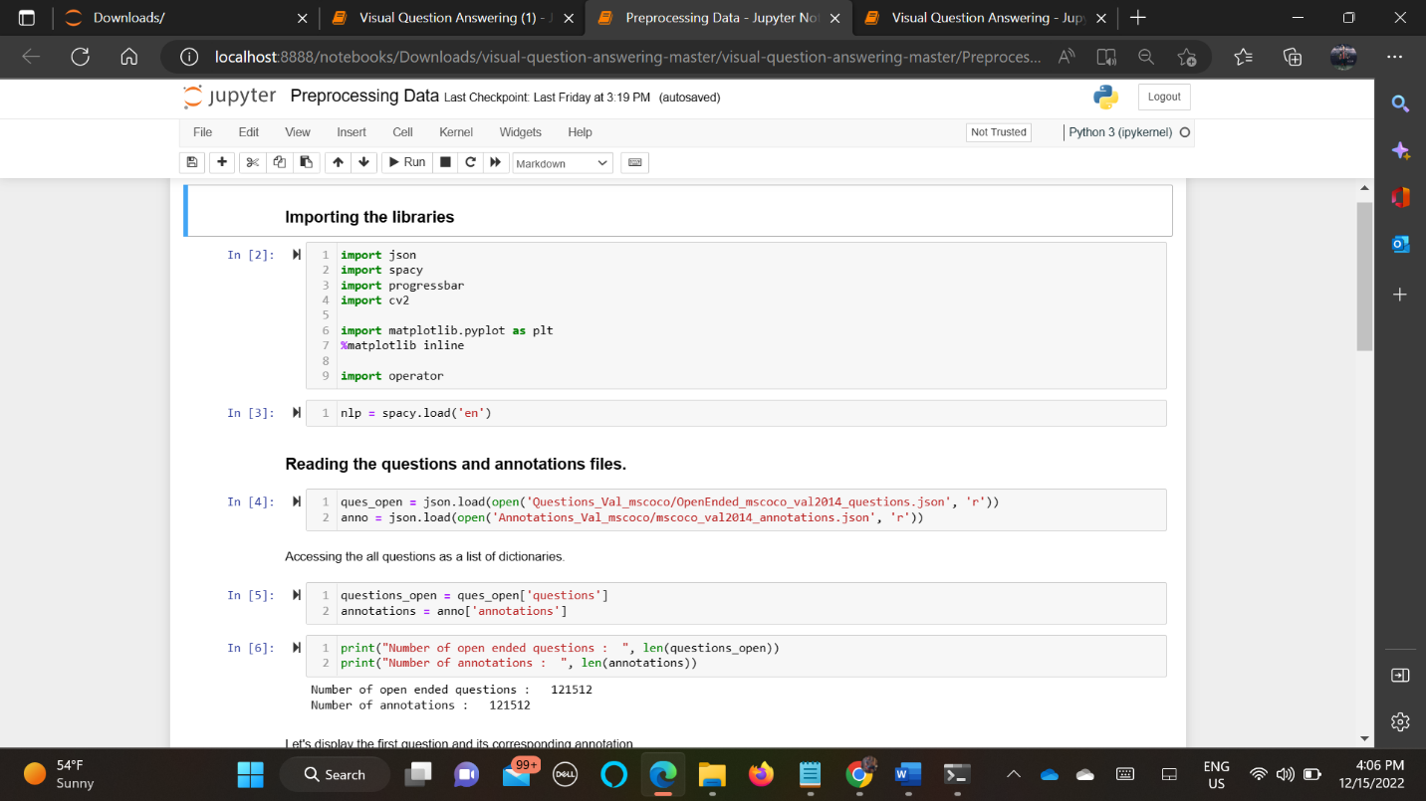

Verifying Any Image That Can Be Displayed from Extracted Json File

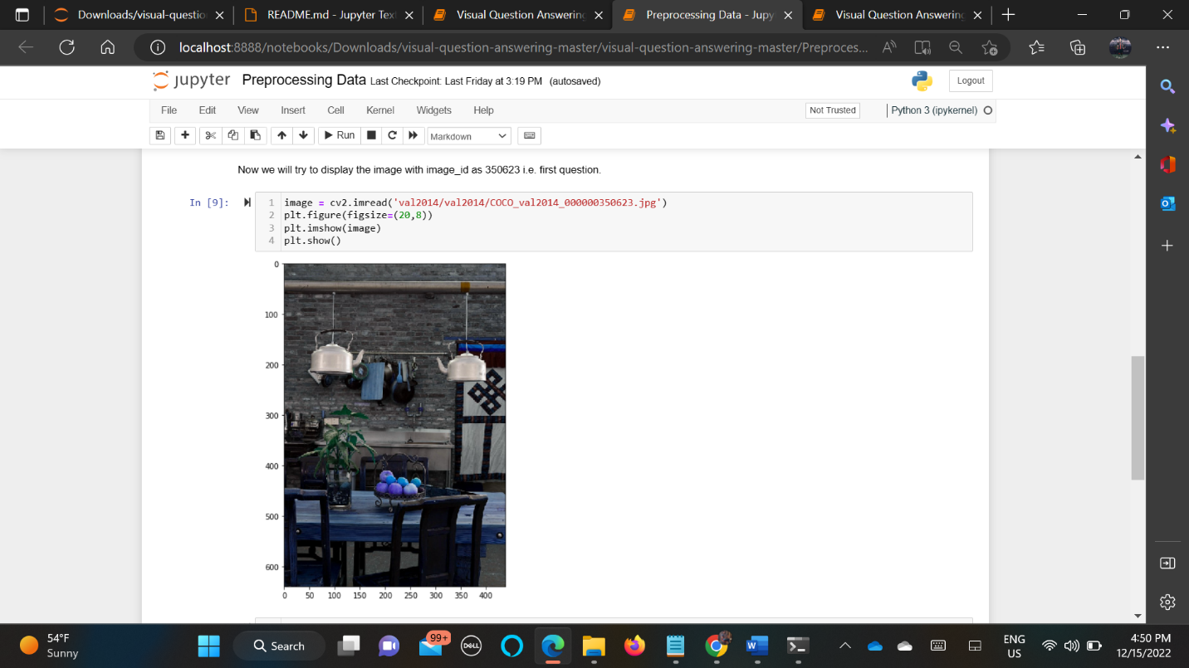

Converted Json File to Txt File For Easy Access

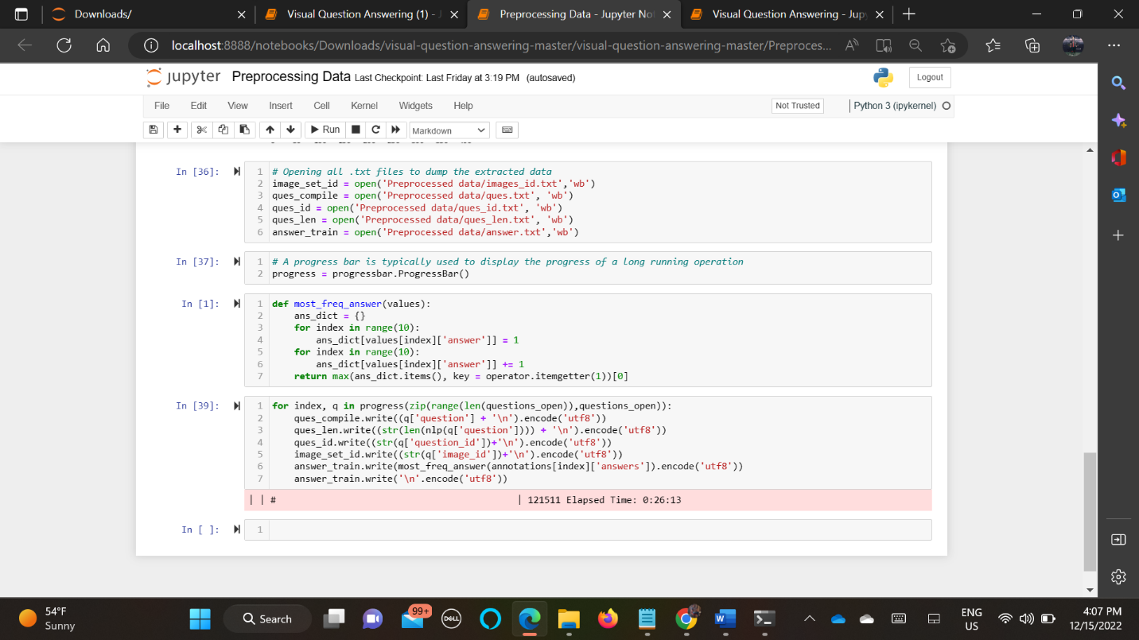

* after all the files are generated, you need to download the vgg_feat.mat vgg model weight
* we then pre-process the data to train and model

Reading the text files that contains extracted questions and annotations

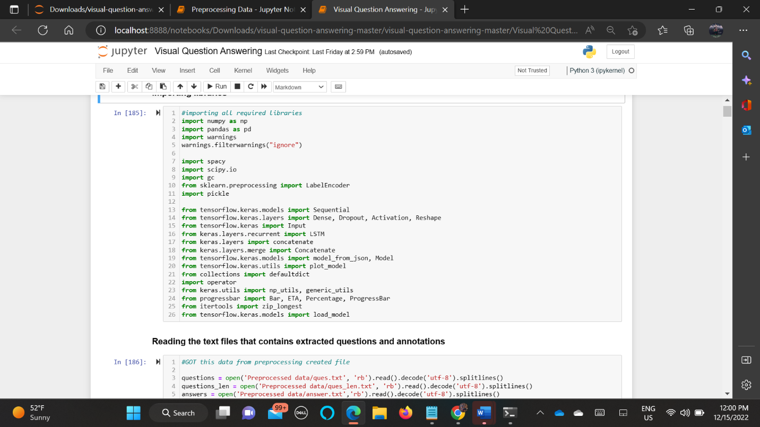

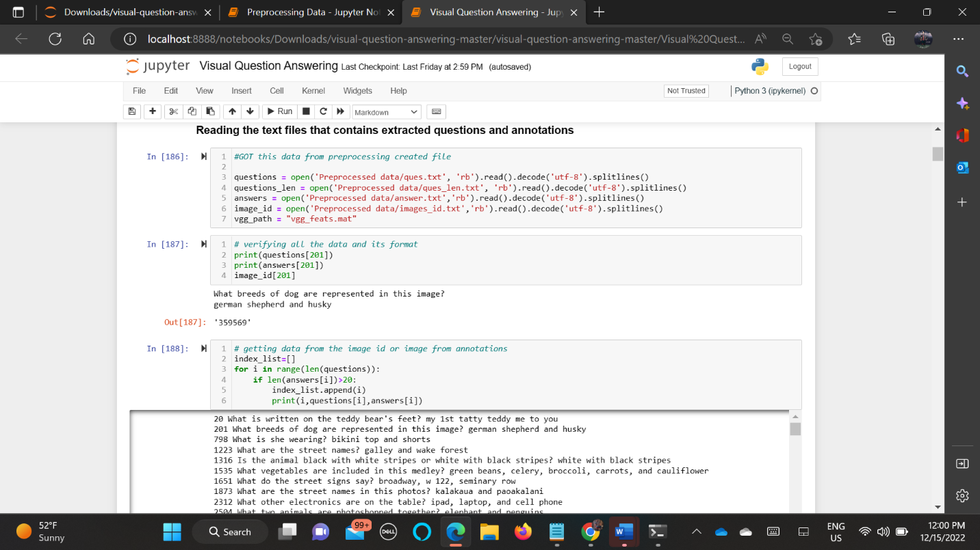

For Most and Frequently Used Words Using Spacy By Creating Pipeline

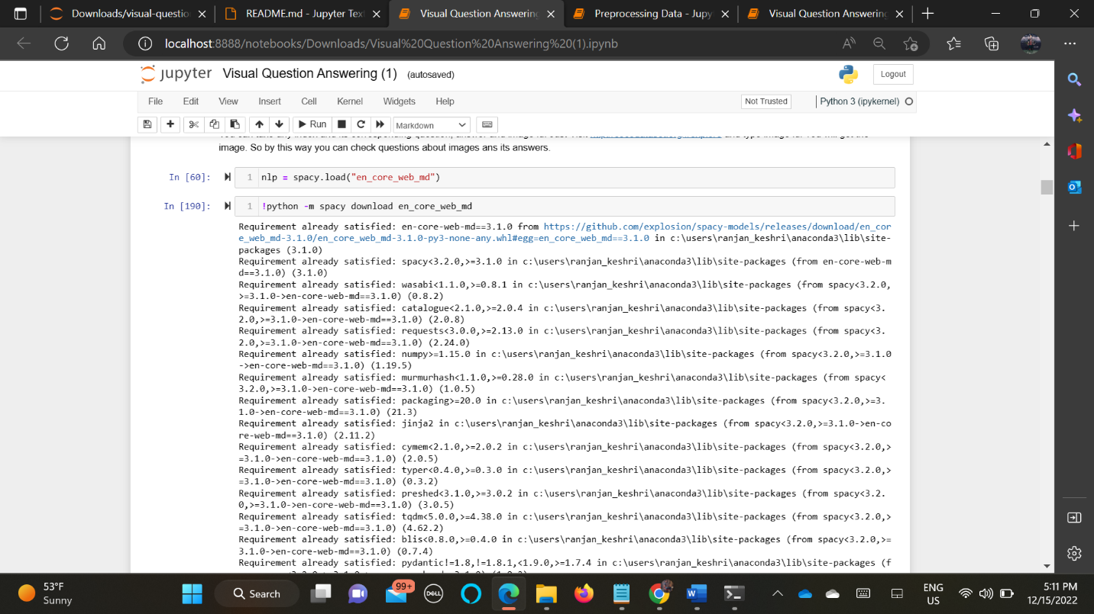

Label Encoding and Defining Parameters:

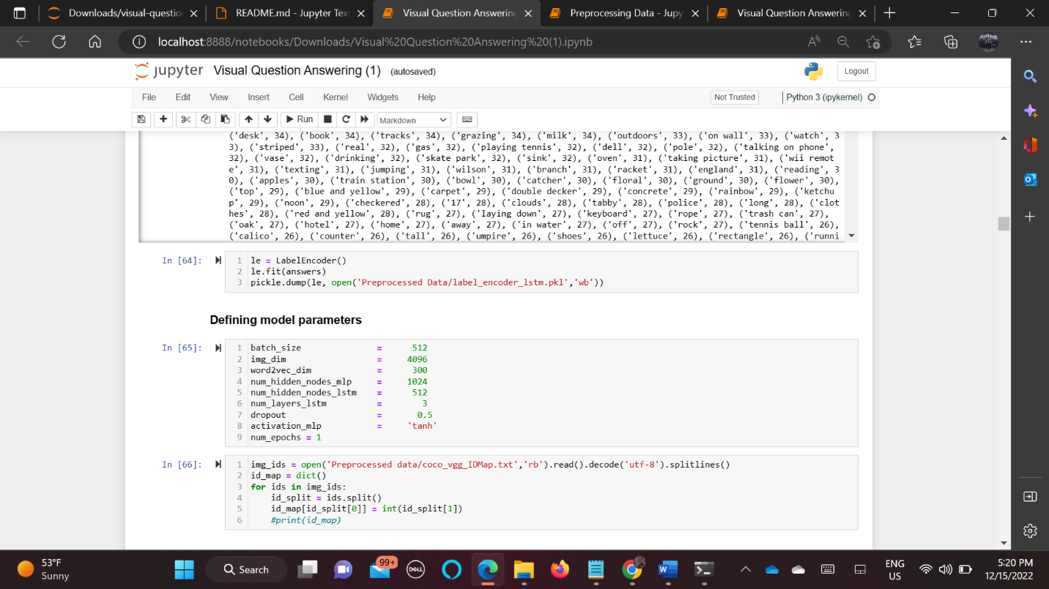

DEFINING ARCHITECTURE:

• a CNN model to encode image into a feature vector v, [10 points]

• an LSTM with word2vec to encode each word in the question qi, [10 points]

• a fusion method to integrate vi and qi into a matrix, [10 points]

• (optional) an MLP classifier to predict the final answer or directly softmax the fused matrix in the last step as the final output.

* Build the model1 for image, model2 for LSTM for question and Y will be train as label encoder
* Then we merge both the model as final model using concatenate and train the model.

This Code Is Completely Written from The Scratch

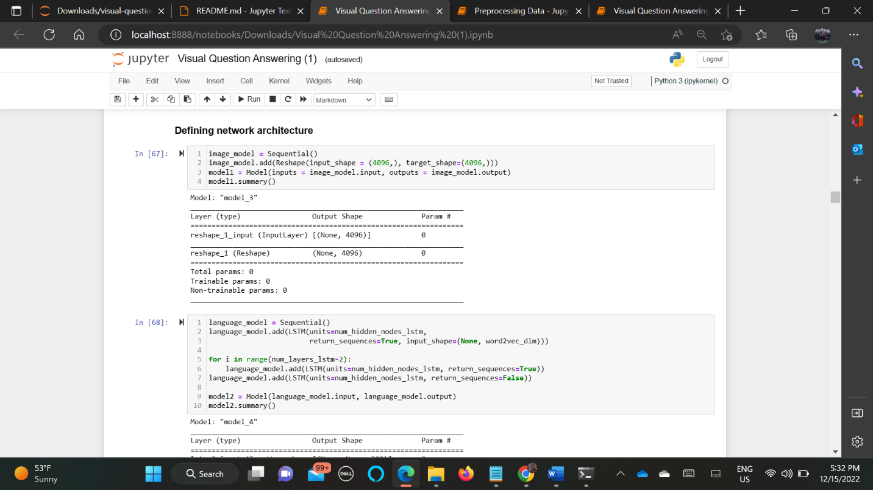

Concatenating Both Models And Activation Function (Softmax) Implementation Fusion Model Implementation (Forming Vi And Qi Matrix) And Mlp

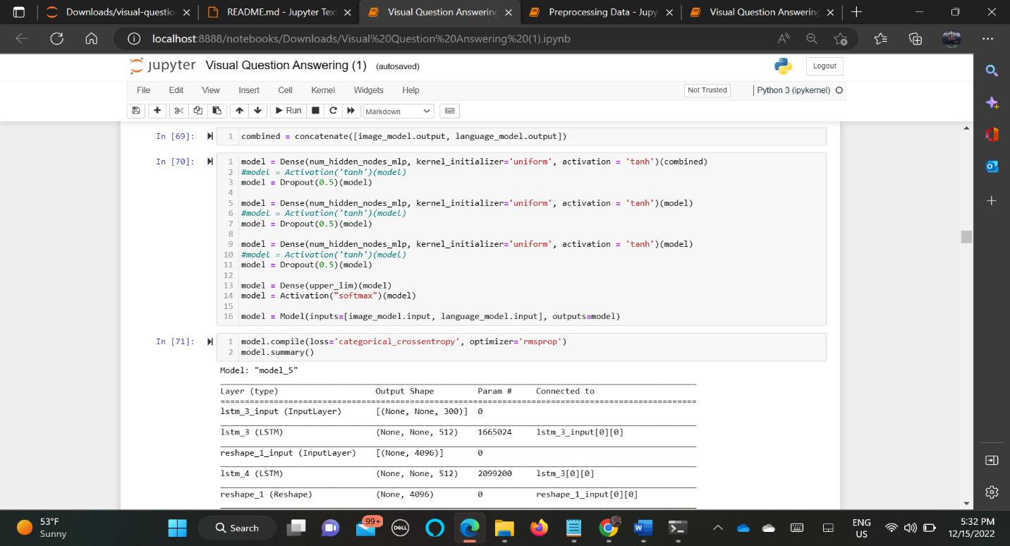

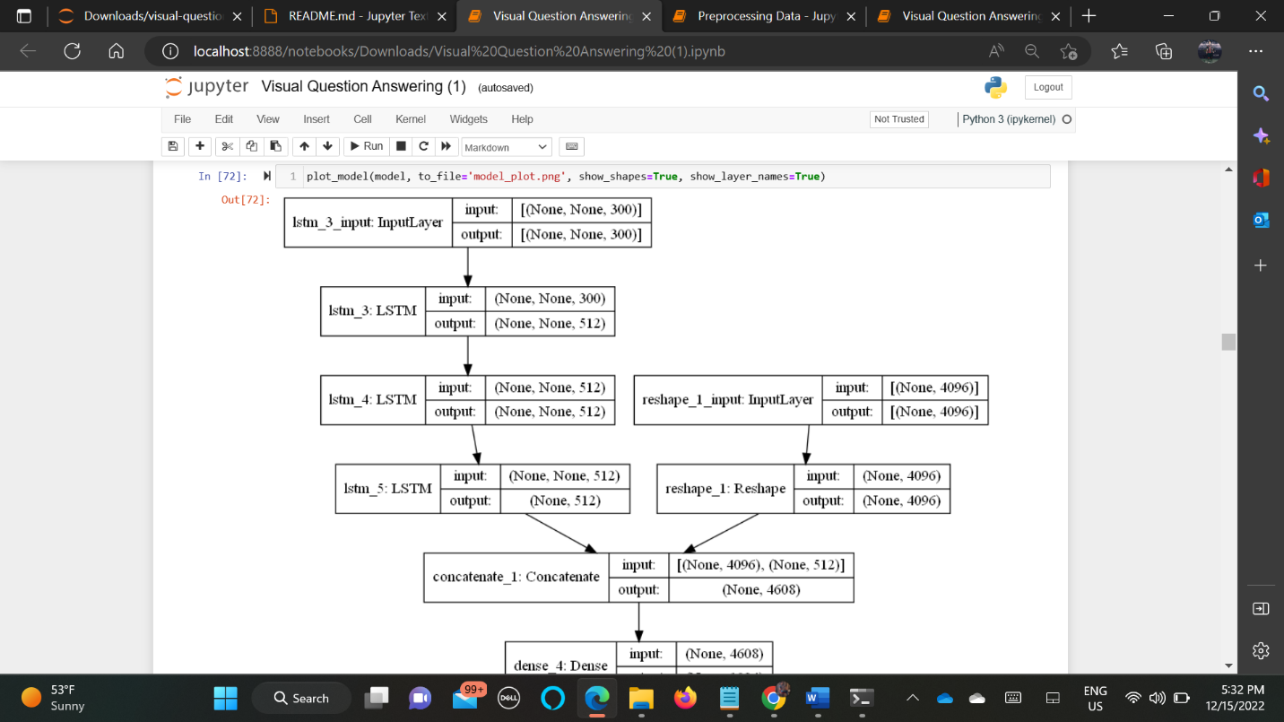

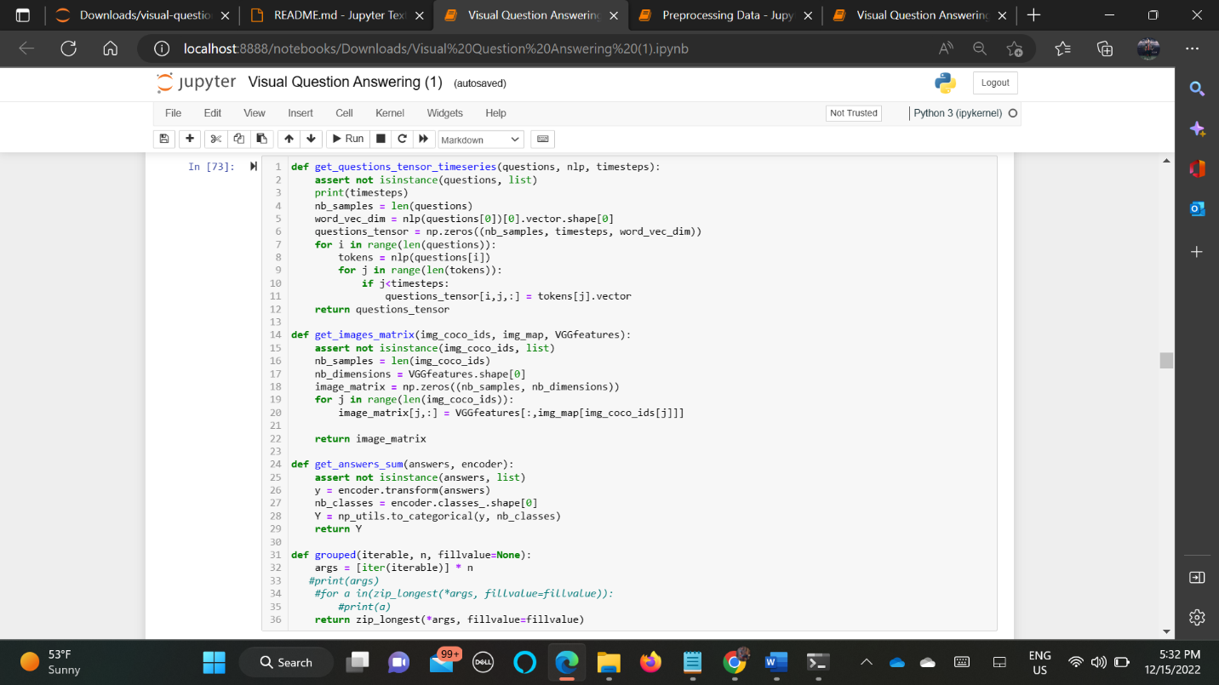

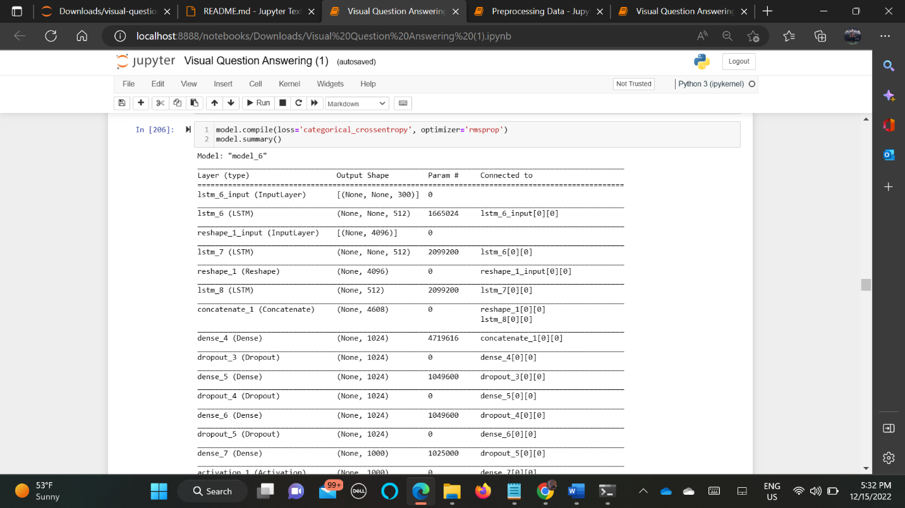

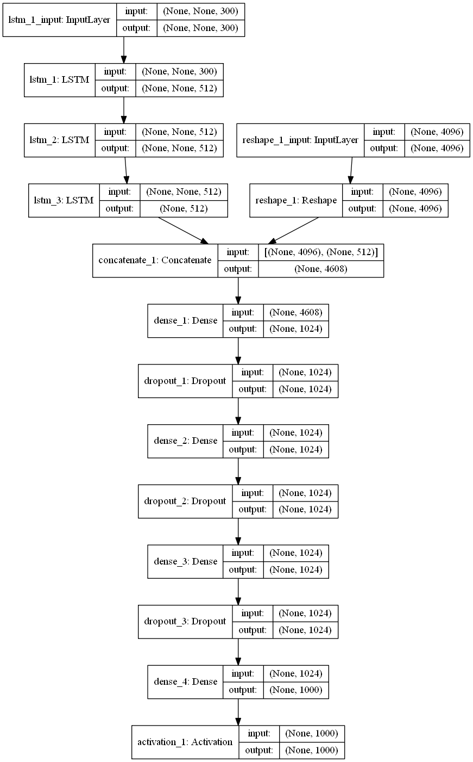

TRAINING AND TESTING AND ACCURACY:

Since We Used Less Accuracy Initially We Got 46.2 % When We Ran 3 Epochs But While Rerunning We Need To Run Only 1 Epoch. So We Can Show The Accuracy Of 36% Only

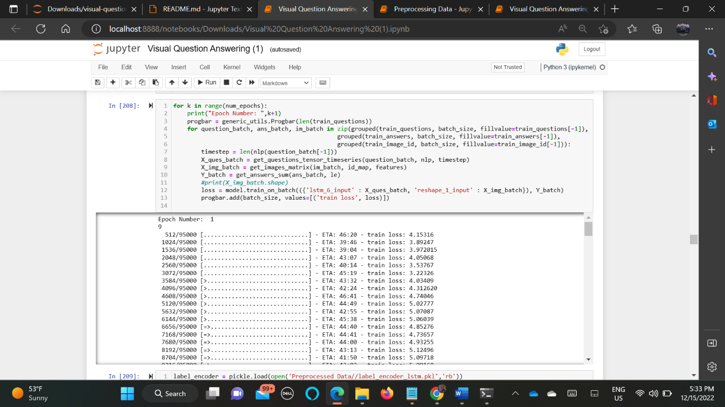

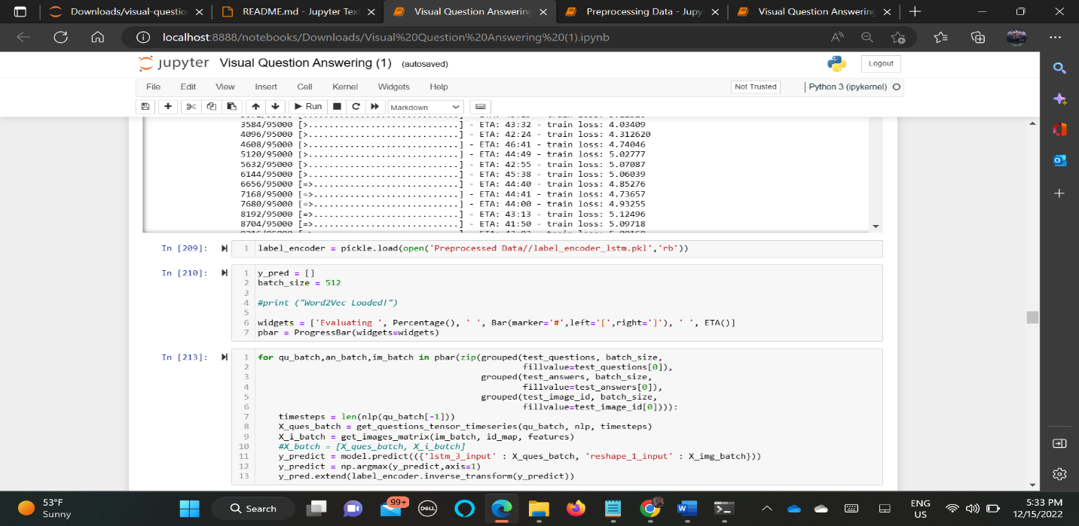

* (optional) an MLP classifier to predict the final answer or directly softmax the fused matrix in the last step as the final output

From This Image You Can See Clearly That Actual Answer and Predicted Answer Is Same. Hence Model Is Running Correctly

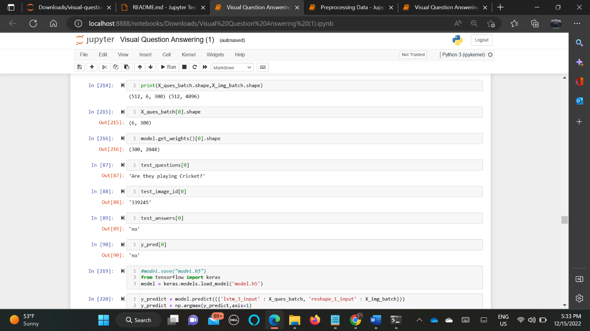

Accuracy of the Model

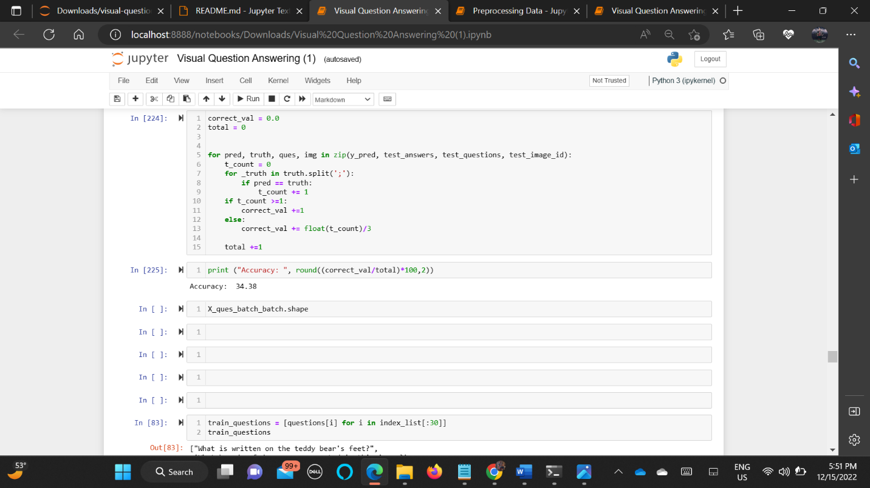

* provide 30 randomly chosen examples from the validation set of VQA v1 dataset. Each example consists of a image, a question, the ground truth answer, the predicted answer, the attention map between the answer and words in the question, and the attention map of input image. [10 points]
* the attention map between answer and question words in previous step indicates correlations among words in the question related to the answer. An example is shown in Fig. 1. In your homework, you only need to plot each word against the whole image instead of regions. [20 points]
* the attention map of input image means a heatmap that can highlight key regions related to the answer. An example is in https://github.com/kapilnchauhan77/CNN-Attention. [20 points]

Checking Initially on One Id First:

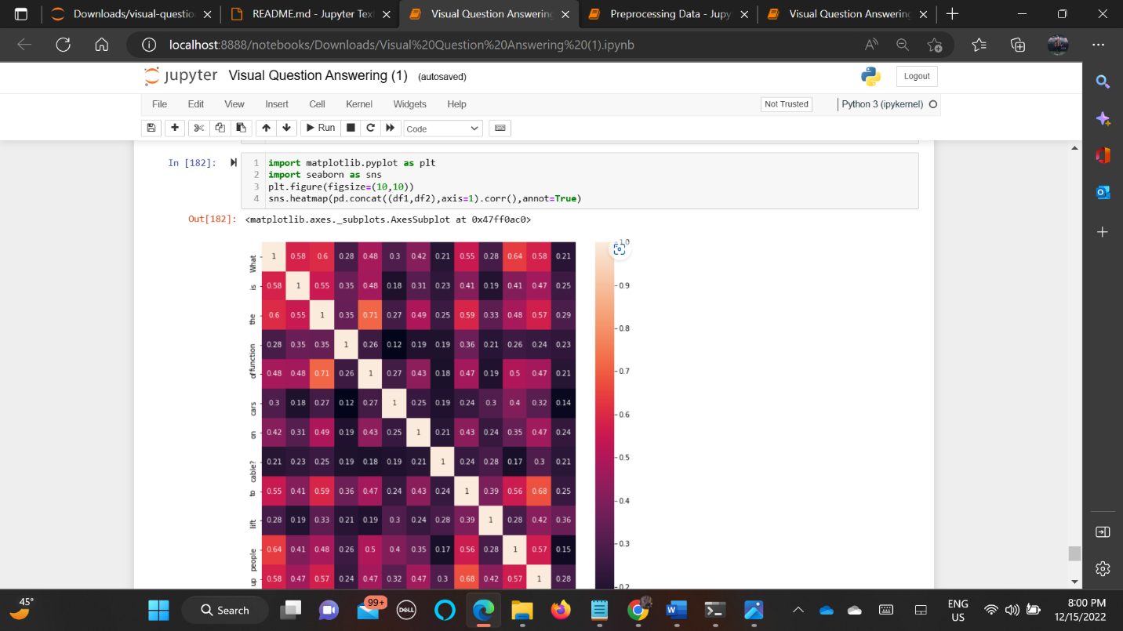

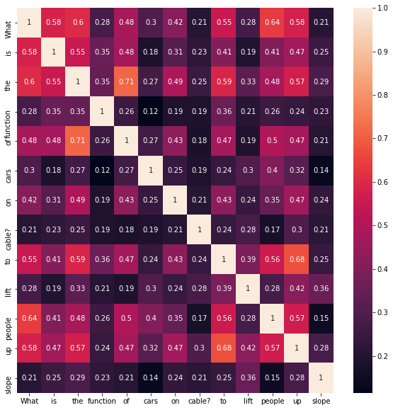

If Plotting Only for Answers

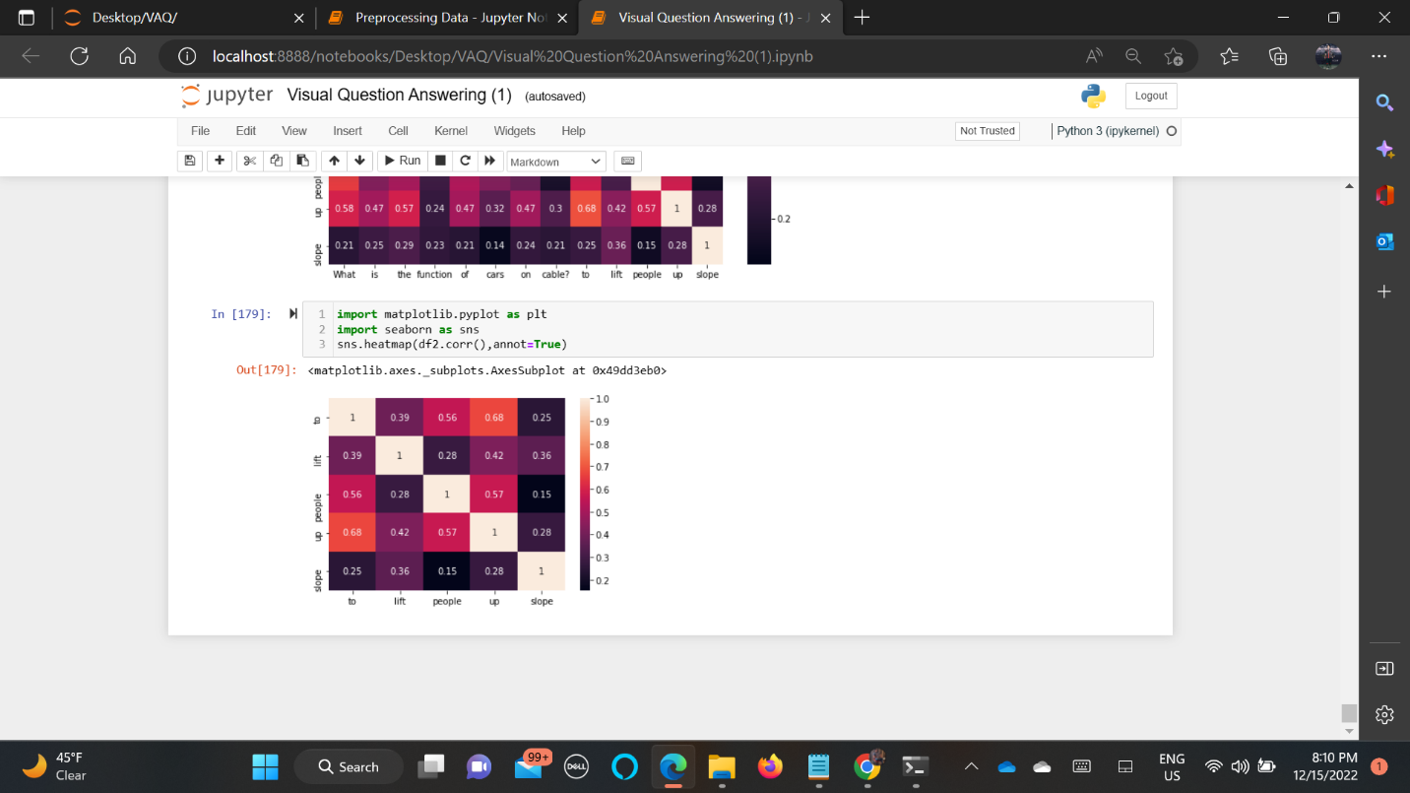

Plotting Questions and Its Predicted Answers and Ground Truth And Its Images And Heat Map

Note: The Letters in White Letters in Heat Map Are Question Words. You Can Have A Look At The Code Screen Shot Of Concat Of Both Question And Answer

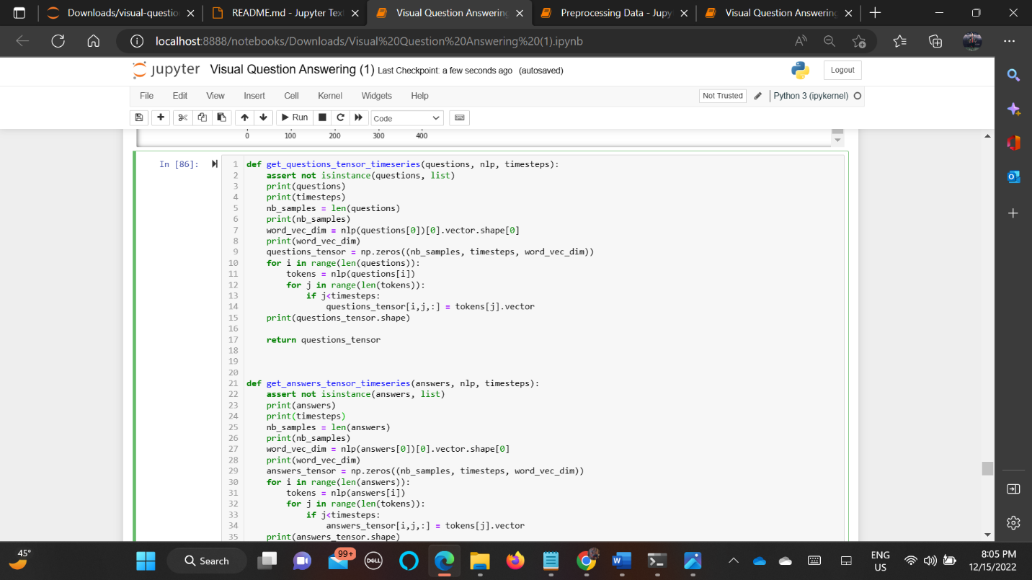

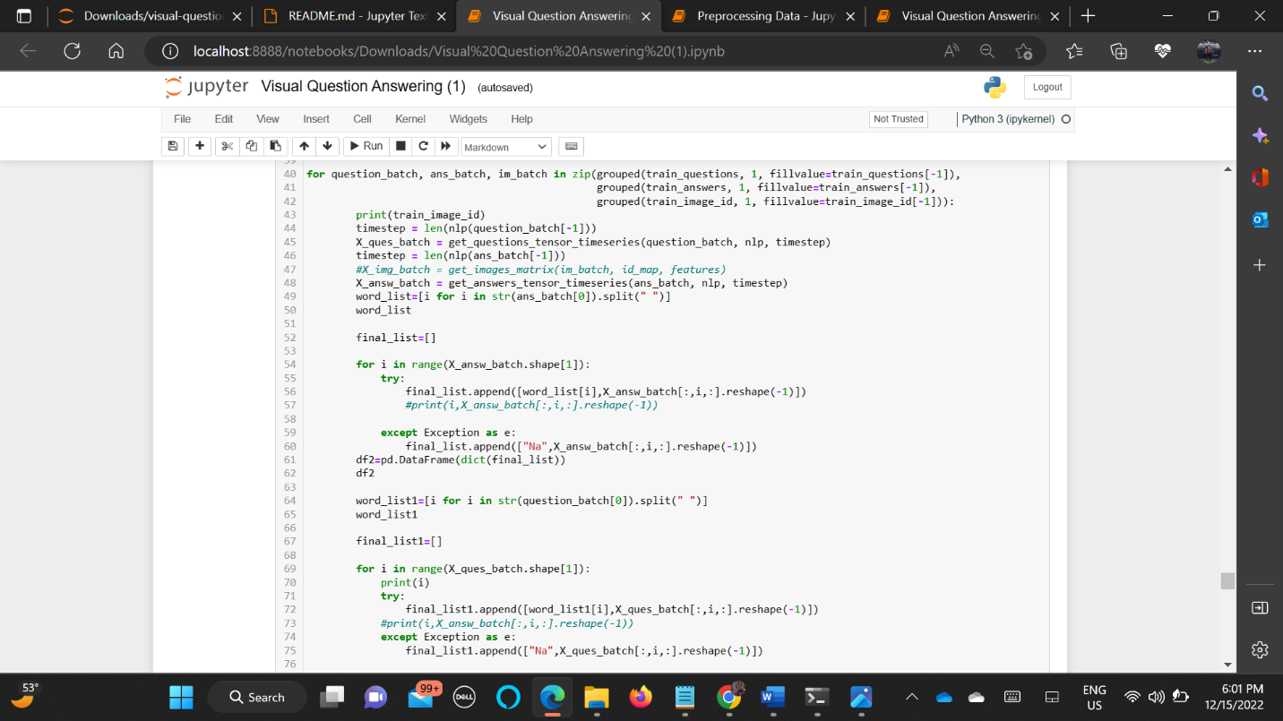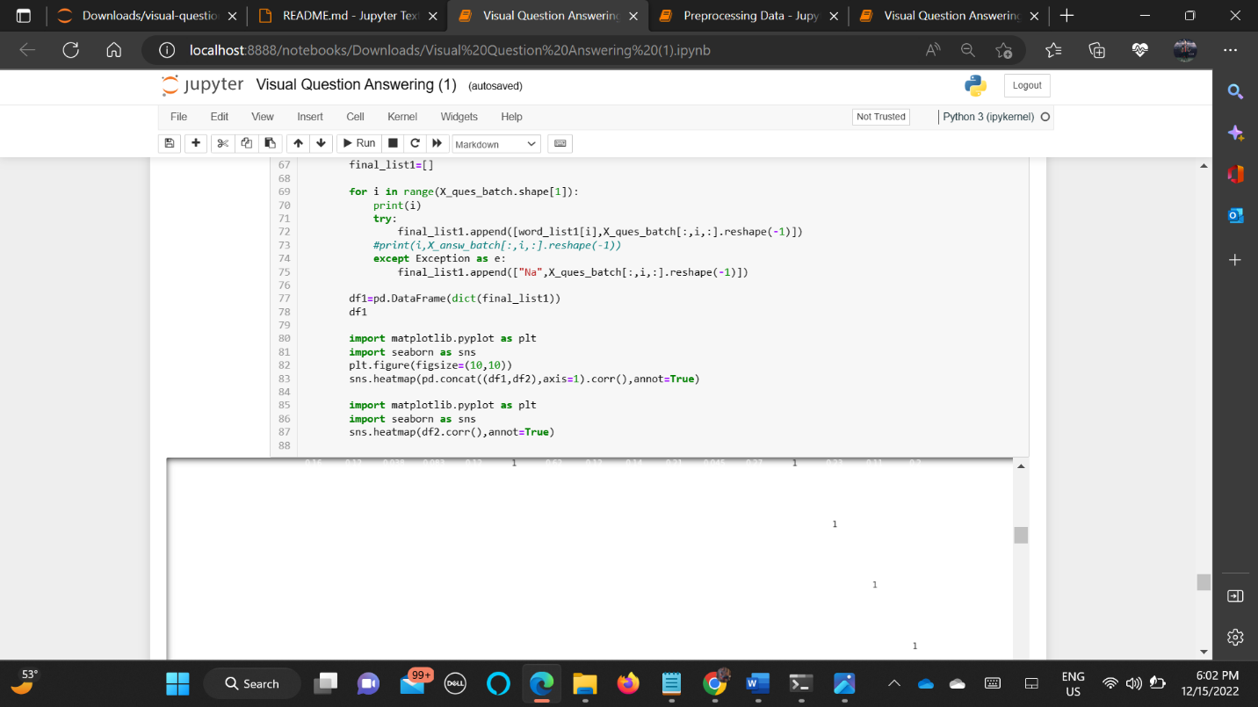

Output Of This Questions:

['124039', '359569', '355660', '37339', '105670', '4936', '500826', '547903', '506803', '505530', '81251', '67956', '209904', '73702', '424668', '115912', '475330', '104494', '207634', '475248', '41128', '37322', '112581', '127984', '69805', '24601', '226111', '179322', '426453', '497514']

124039

(358, 500, 3)

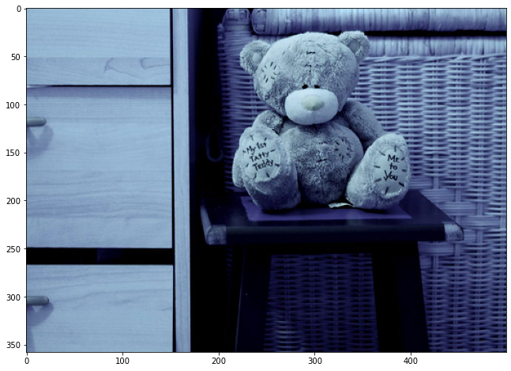

("What is written on the teddy bear's feet?",)

10

1

300

(1, 10, 300)

('my 1st tatty teddy me to you',)

7

('my 1st tatty teddy me to you')

1

300

(1, 7, 300)

0

1

2

3

4

5

6

7

8

9

Note: The Letters in White Letters In Heat Map Are Question Words. You Can Have a Look At The Code Screen Shot Of Concat Of Both Question And Answer

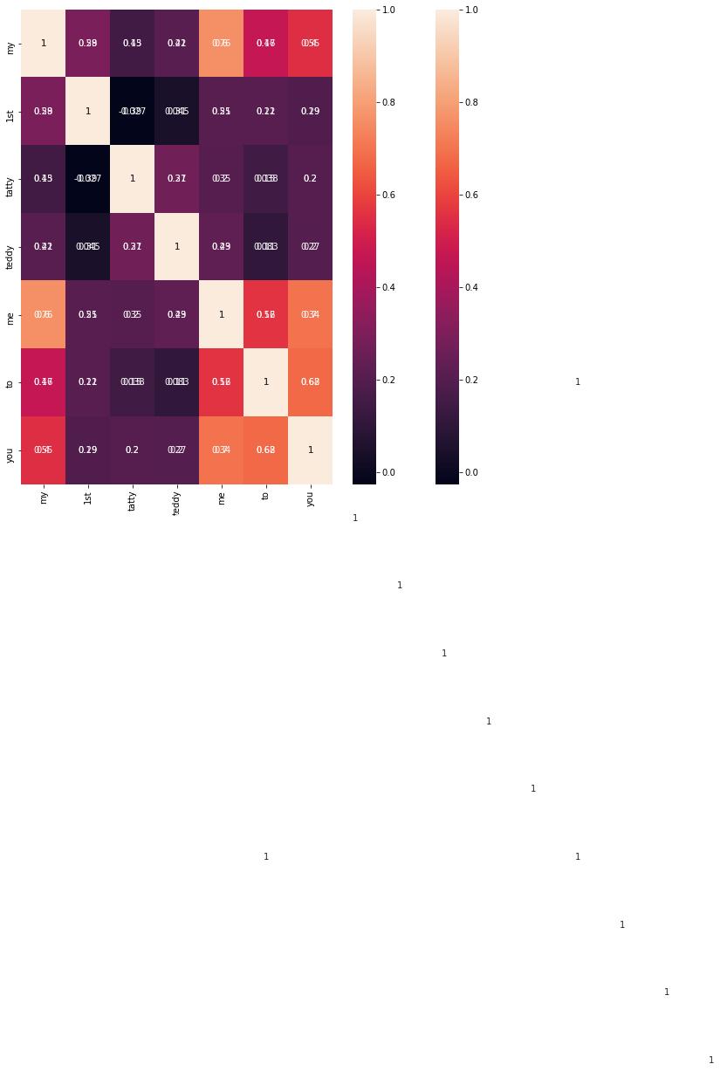

['124039', '359569', '355660', '37339', '105670', '4936', '500826', '547903', '506803', '505530', '81251', '67956', '209904', '73702', '424668', '115912', '475330', '104494', '207634', '475248', '41128', '37322', '112581', '127984', '69805', '24601', '226111', '179322', '426453', '497514']

359569

(480, 640, 3)

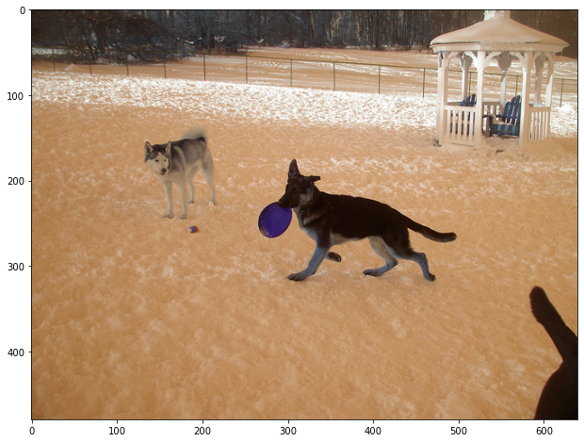

('What breeds of dog are represented in this image?',)

10

1

300

(1, 10, 300)

('german shepherd and husky',)

4

('german shepherd and husky')

1

300

(1, 4, 300)

0

1

2

3

4

5

6

7

8

9



['124039', '359569', '355660', '37339', '105670', '4936', '500826', '547903', '506803', '505530', '81251', '67956', '209904', '73702', '424668', '115912', '475330', '104494', '207634', '475248', '41128', '37322', '112581', '127984', '69805', '24601', '226111', '179322', '426453', '497514']

355660

(427, 640, 3)

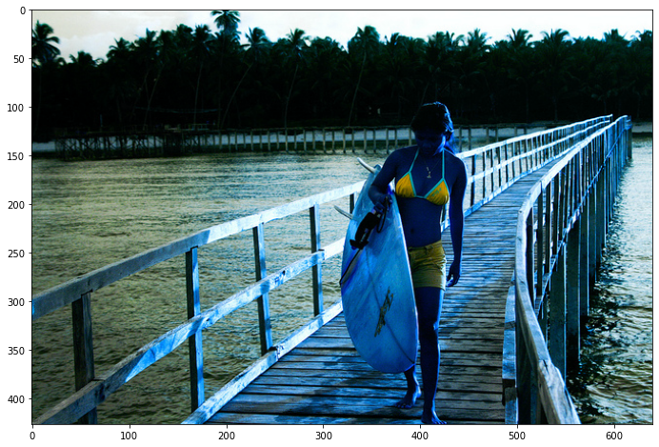

('What is she wearing?',)

5

1

300

(1, 5, 300)

('bikini top and shorts',)

4

('yellow,blue')

1

300

(1, 4, 300)

0

1

2

3

4

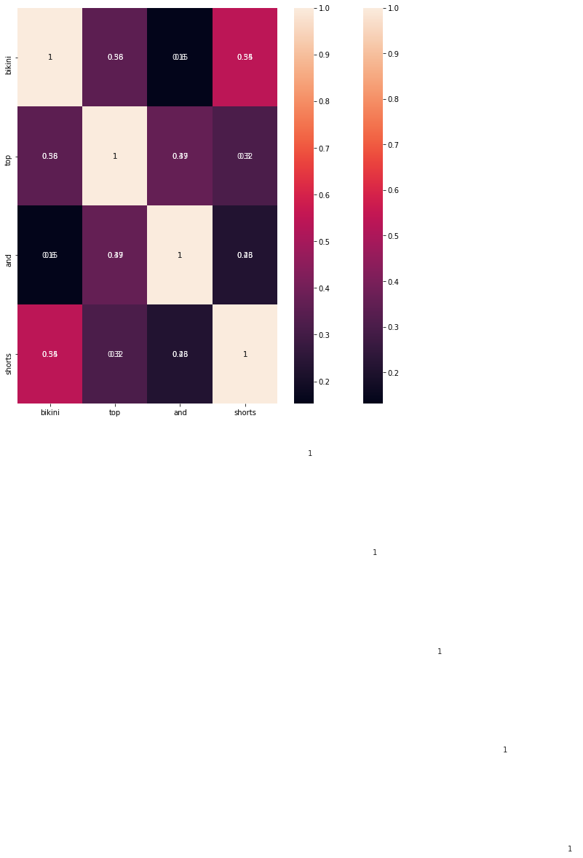

['124039', '359569', '355660', '37339', '105670', '4936', '500826', '547903', '506803', '505530', '81251', '67956', '209904', '73702', '424668', '115912', '475330', '104494', '207634', '475248', '41128', '37322', '112581', '127984', '69805', '24601', '226111', '179322', '426453', '497514']

('What are the street names?',)

6

1

300

(1, 6, 300)

('galley and wake forest',)

4

('yes')

1

300

(1, 4, 300)

0

1

2

3

4

5

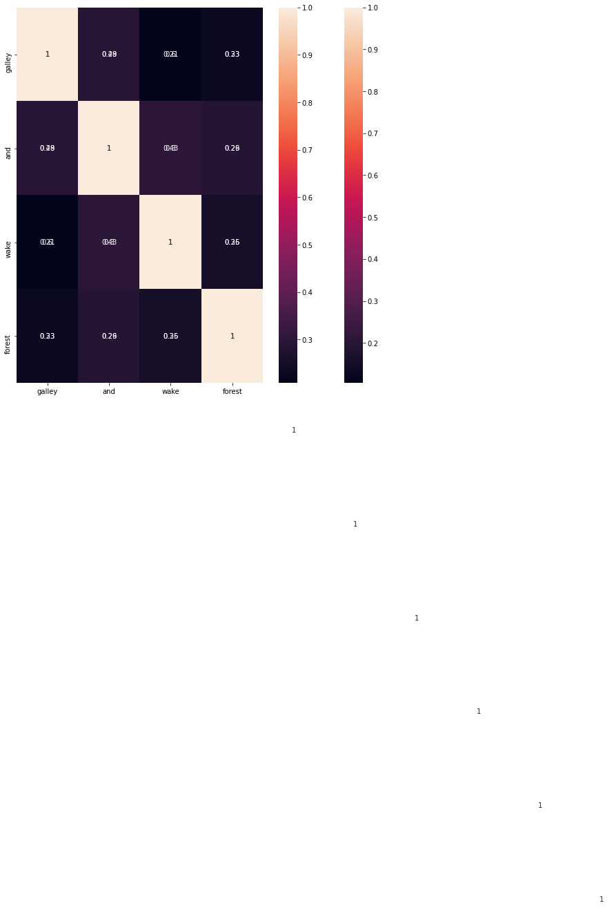

['124039', '359569', '355660', '37339', '105670', '4936', '500826', '547903', '506803', '505530', '81251', '67956', '209904', '73702', '424668', '115912', '475330', '104494', '207634', '475248', '41128', '37322', '112581', '127984', '69805', '24601', '226111', '179322', '426453', '497514']

37339

105670

(640, 415, 3)

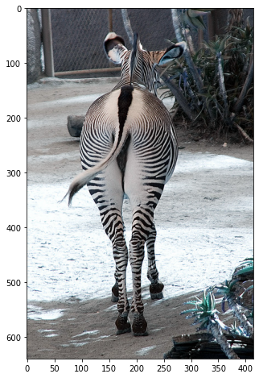

('Is the animal black with white stripes or white with black stripes?',)

13

1

300

(1, 13, 300)

('white with black stripes',)

4

('white with black stripes')

1

300

(1, 4, 300)

0

1

2

3

4

5

6

7

8

9

10

11

12



['124039', '359569', '355660', '37339', '105670', '4936', '500826', '547903', '506803', '505530', '81251', '67956', '209904', '73702', '424668', '115912', '475330', '104494', '207634', '475248', '41128', '37322', '112581', '127984', '69805', '24601', '226111', '179322', '426453', '497514']

('What vegetables are included in this medley?',)

105670

(480, 640, 3)

8

1

300

(1, 8, 300)

('green beans, celery, broccoli, carrots, and cauliflower',)

11

('no')

1

300

(1, 11, 300)

0

1

2

3

4

5

6

7

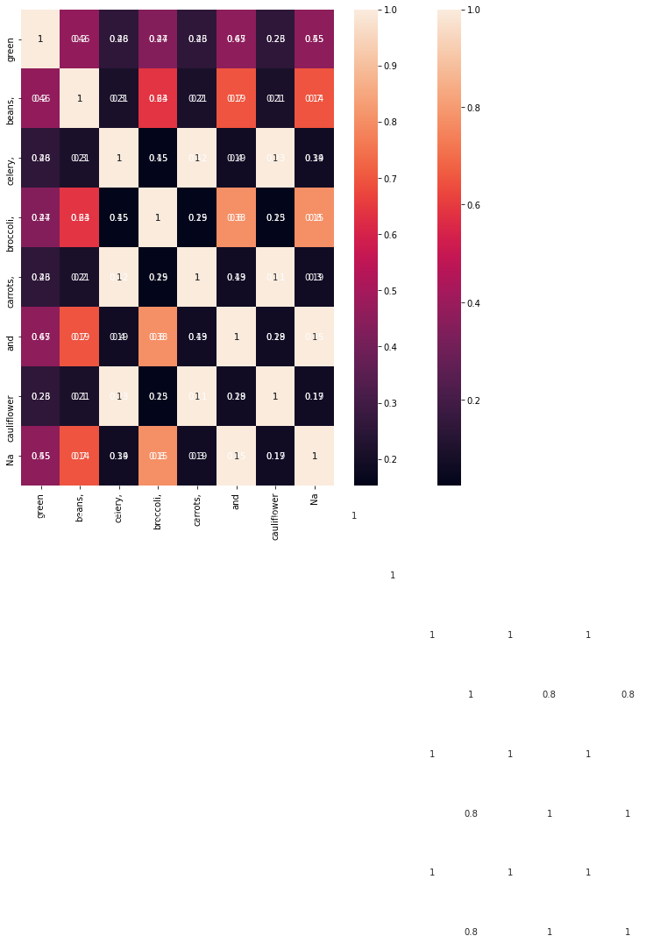

['124039', '359569', '355660', '37339', '105670', '4936', '500826', '547903', '506803', '505530', '81251', '67956', '209904', '73702', '424668', '115912', '475330', '104494', '207634', '475248', '41128', '37322', '112581', '127984', '69805', '24601', '226111', '179322', '426453', '497514']

4936

500826

(426, 640, 3)

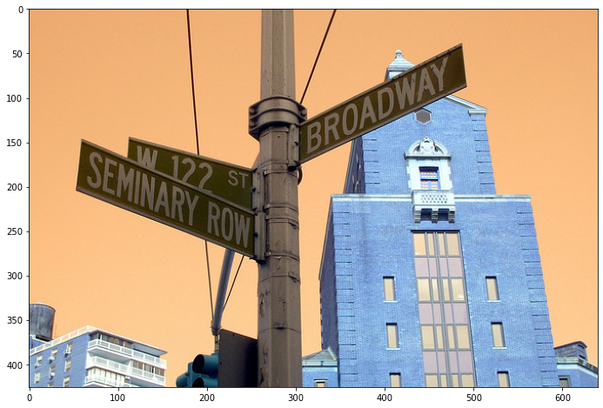

('What do the street signs say?',)

7

1

300

(1, 7, 300)

('broadway, w 122, seminary row',)

7

('broadway, w 122, seminary row',)

1

300

(1, 7, 300)

0

1

2

3

4

5

6

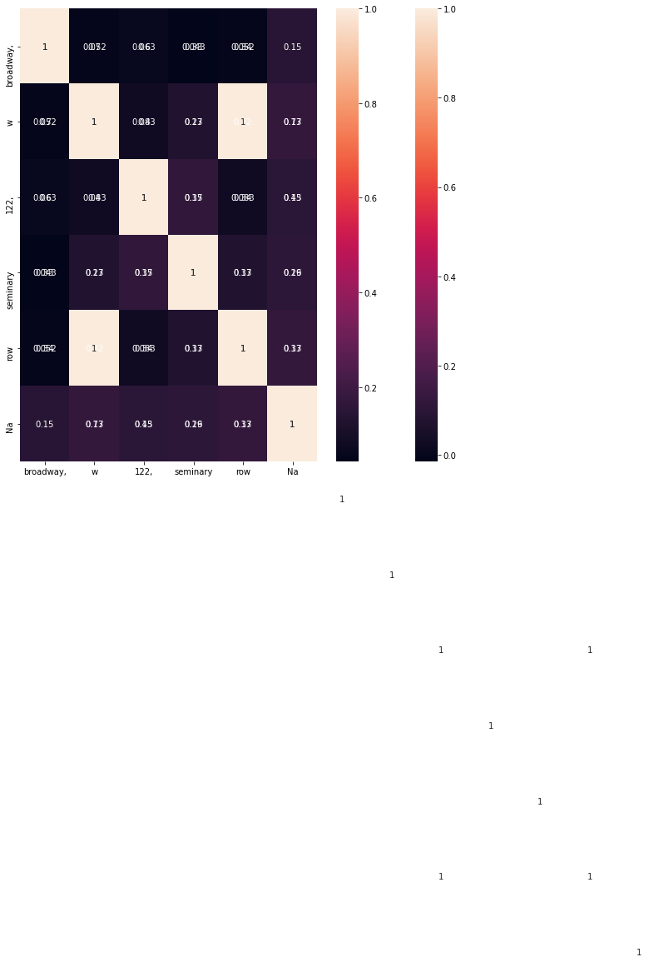

['124039', '359569', '355660', '37339', '105670', '4936', '500826', '547903', '506803', '505530', '81251', '67956', '209904', '73702', '424668', '115912', '475330', '104494', '207634', '475248', '41128', '37322', '112581', '127984', '69805', '24601', '226111', '179322', '426453', '497514']

547903

(480, 640, 3)

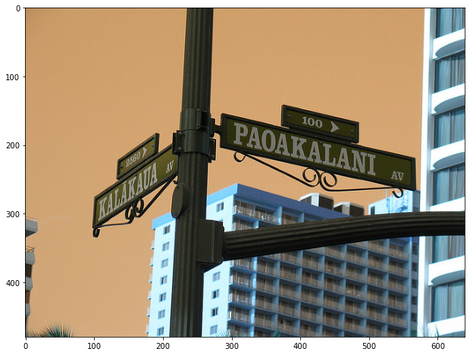

('What are the street names in this photos?',)

9

1

300

(1, 9, 300)

('kalakaua and paoakalani',)

3

('kalakaua and paoakalani',)

1

300

(1, 3, 300)

0

1

2

3

4

5

6

7

8



['124039', '359569', '355660', '37339', '105670', '4936', '500826', '547903', '506803', '505530', '81251', '67956', '209904', '73702', '424668', '115912', '475330', '104494', '207634', '475248', '41128', '37322', '112581', '127984', '69805', '24601', '226111', '179322', '426453', '497514']

506803

(480, 640, 3)

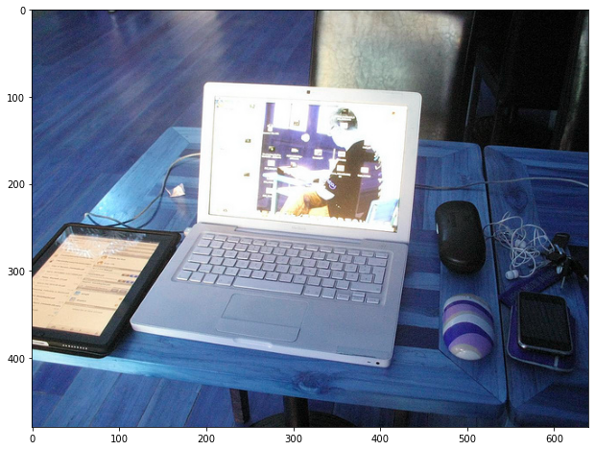

('What other electronics are on the table?',)

8

1

300

(1, 8, 300)

('ipad, laptop, and cell phone',)

7

('ipad, laptop, and cell phone',)

1

300

(1, 7, 300)

0

1

2

3

4

5

6

7

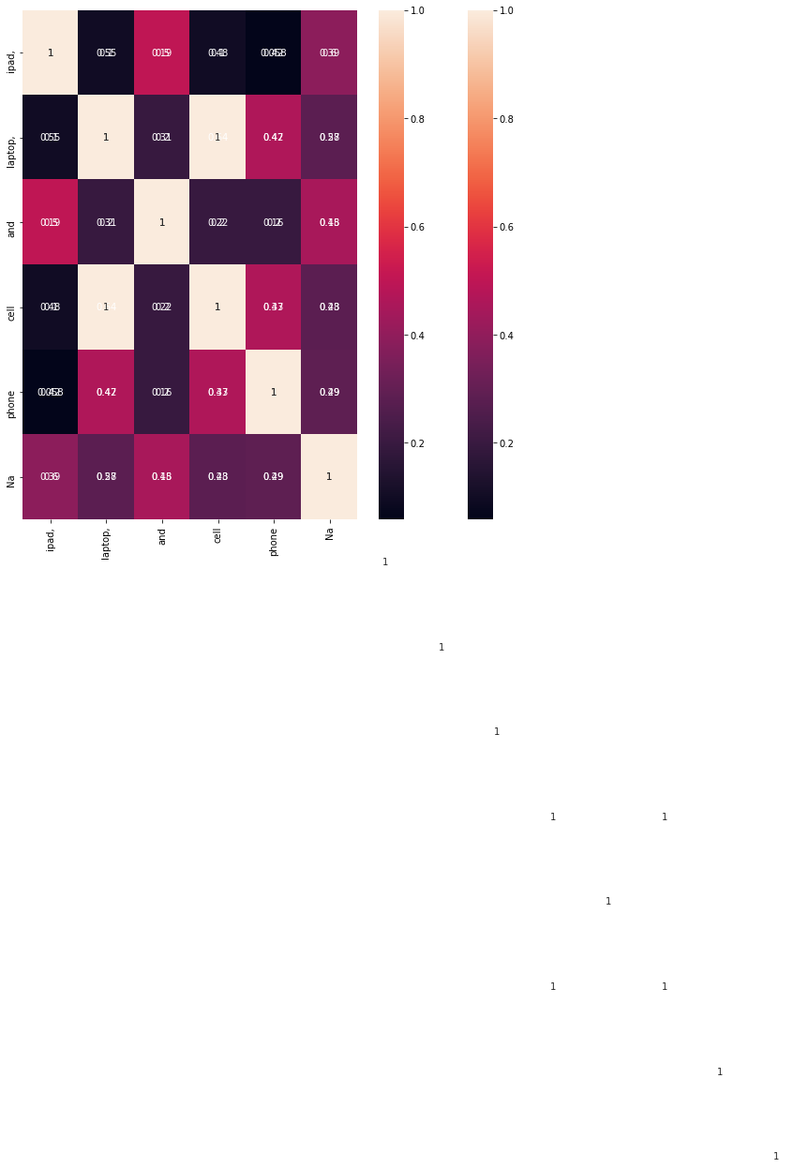

['124039', '359569', '355660', '37339', '105670', '4936', '500826', '547903', '506803', '505530', '81251', '67956', '209904', '73702', '424668', '115912', '475330', '104494', '207634', '475248', '41128', '37322', '112581', '127984', '69805', '24601', '226111', '179322', '426453', '497514']

505530

(435, 640, 3)

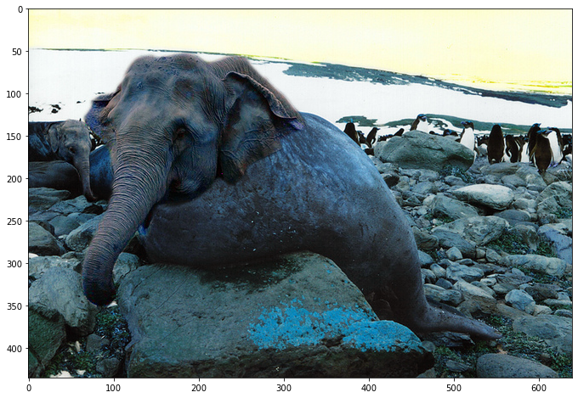

('What two animals are photoshopped together?',)

7

1

300

(1, 7, 300)

('elephant and penguins',)

3

('elephant and penguins',)

1

300

(1, 3, 300)

0

1

2

3

4

5

6



['124039', '359569', '355660', '37339', '105670', '4936', '500826', '547903', '506803', '505530', '81251', '67956', '209904', '73702', '424668', '115912', '475330', '104494', '207634', '475248', '41128', '37322', '112581', '127984', '69805', '24601', '226111', '179322', '426453', '497514']

('What kind of pizza is this?',)

7

1

300

(1, 7, 300)

('tomato, mozzarella, and spinach',)

6

('no')

1

300

(1, 6, 300)

0

1

2

3

4

5

6

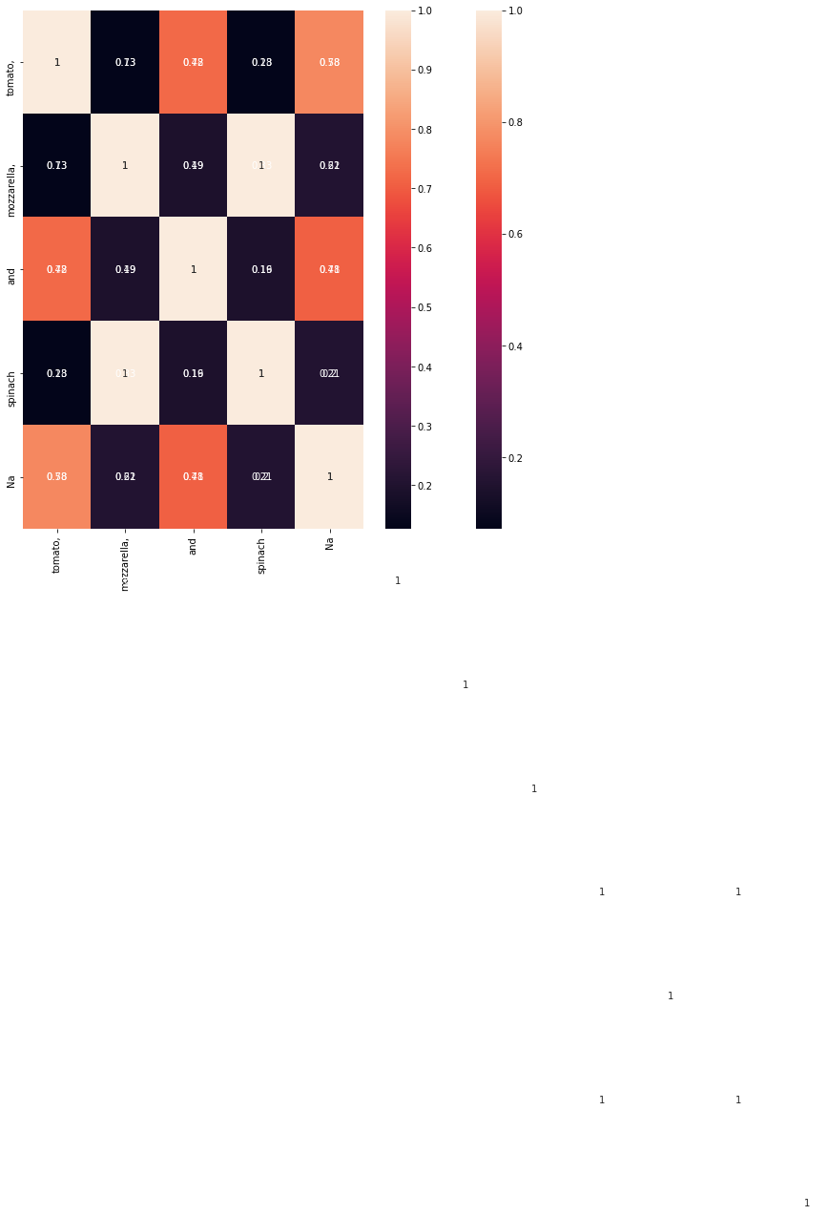

['124039', '359569', '355660', '37339', '105670', '4936', '500826', '547903', '506803', '505530', '81251', '67956', '209904', '73702', '424668', '115912', '475330', '104494', '207634', '475248', '41128', '37322', '112581', '127984', '69805', '24601', '226111', '179322', '426453', '497514']

('What does the sign say below the Stop Sign?',)

10

1

300

(1, 10, 300)

('opposing traffic does not stop',)

5

('none')

1

300

(1, 5, 300)

0

1

2

3

4

5

6

7

8

9

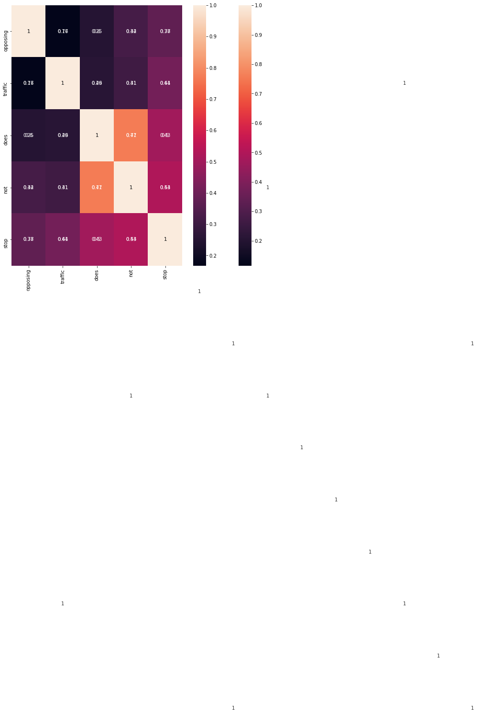

['124039', '359569', '355660', '37339', '105670', '4936', '500826', '547903', '506803', '505530', '81251', '67956', '209904', '73702', '424668', '115912', '475330', '104494', '207634', '475248', '41128', '37322', '112581', '127984', '69805', '24601', '226111', '179322', '426453', '497514']

81251

67956

209904

(480, 640, 3)

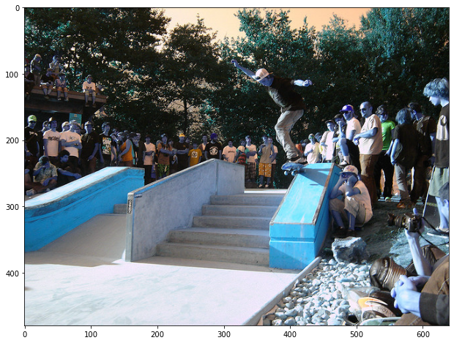

('Where are the people in the picture?',)

8

1

300

(1, 8, 300)

('behind and beside skateboarder',)

4

('behind and beside skateboarder',)

1

300

(1, 4, 300)

0

1

2

3

4

5

6

7

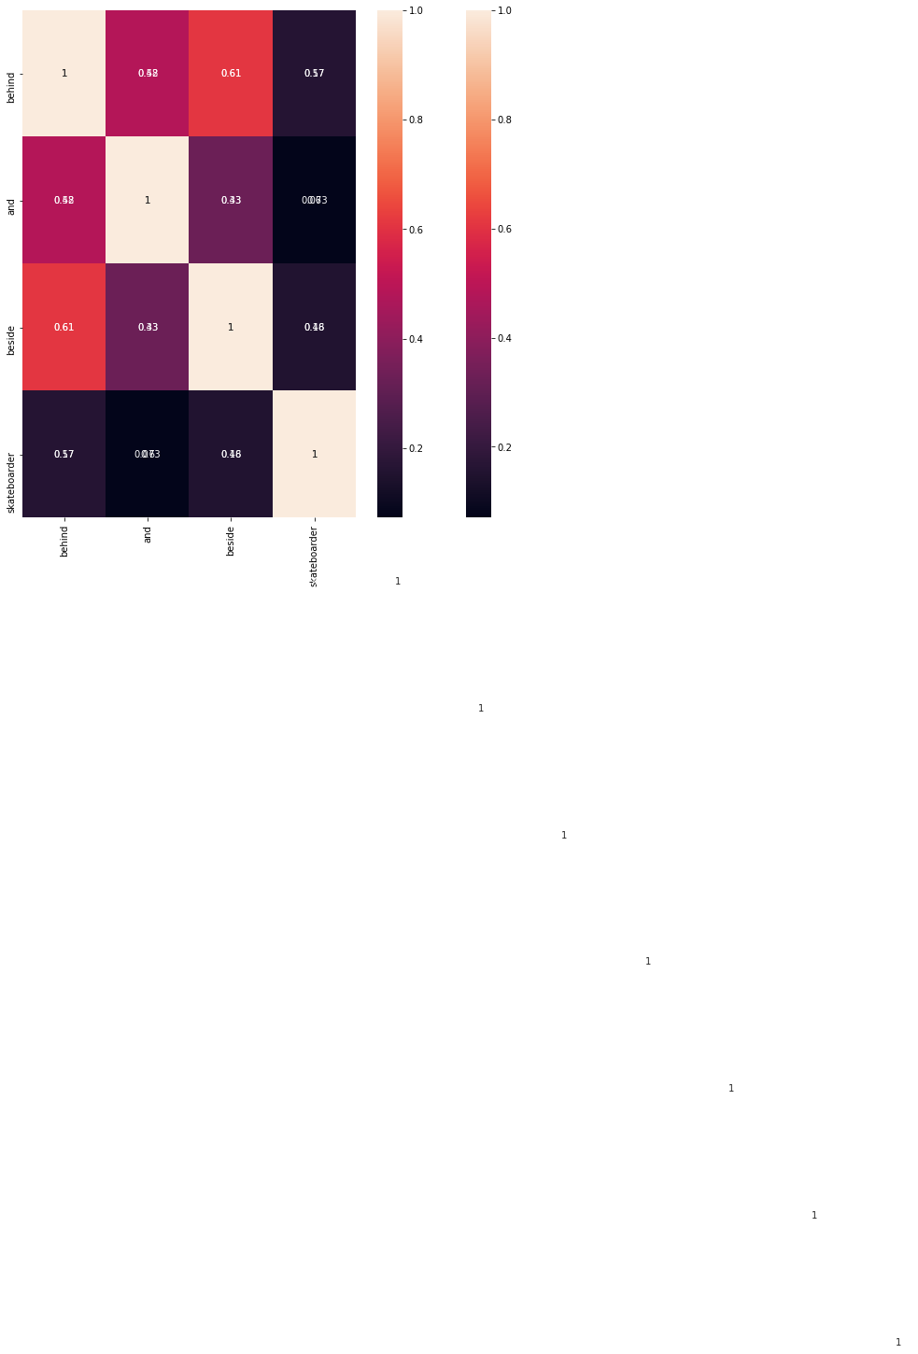

['124039', '359569', '355660', '37339', '105670', '4936', '500826', '547903', '506803', '505530', '81251', '67956', '209904', '73702', '424668', '115912', '475330', '104494', '207634', '475248', '41128', '37322', '112581', '127984', '69805', '24601', '226111', '179322', '426453', '497514']

('What color are on the umbrellas?',)

7

1

300

(1, 7, 300)

('red, blue, green, yellow',)

7

('red,grey',)

1

300

(1, 7, 300)

0

1

2

3

4

5

6

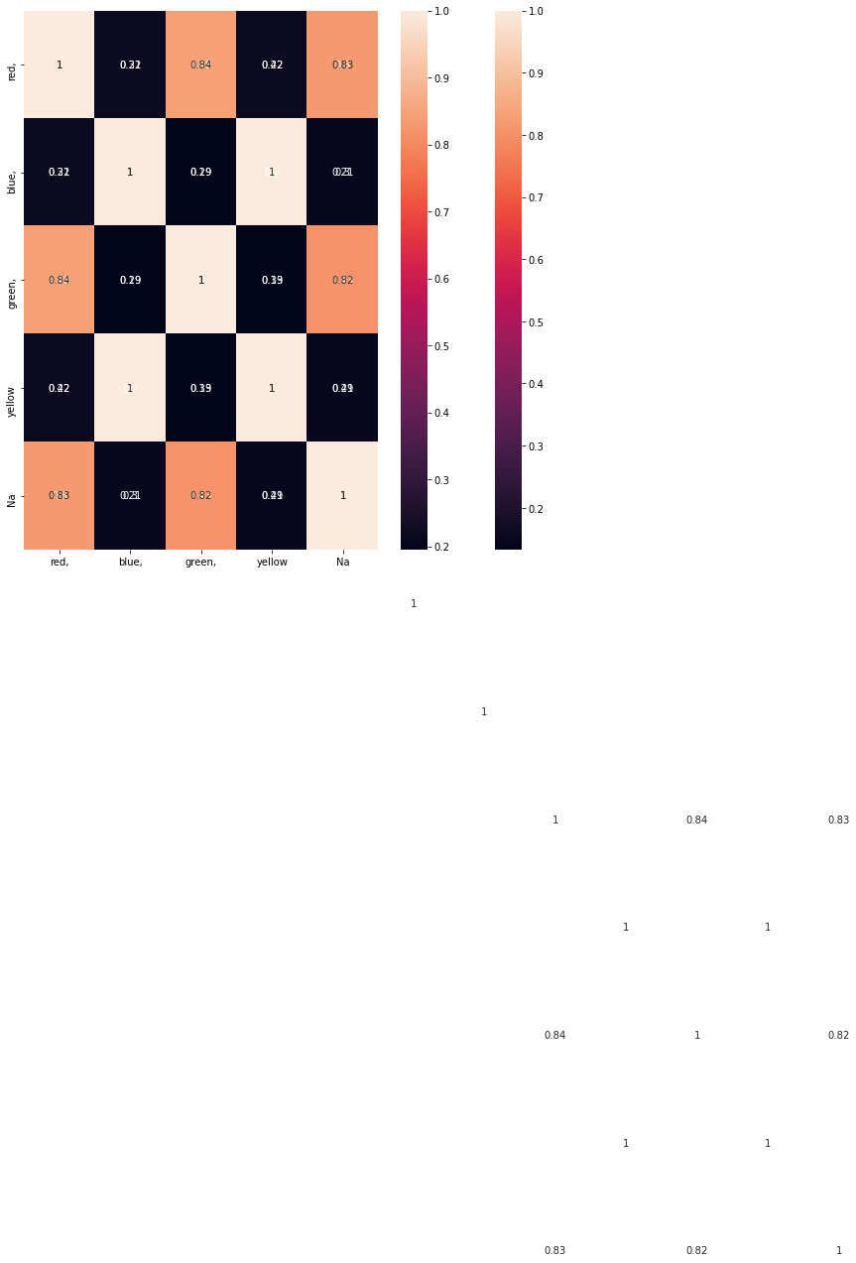

['124039', '359569', '355660', '37339', '105670', '4936', '500826', '547903', '506803', '505530', '81251', '67956', '209904', '73702', '424668', '115912', '475330', '104494', '207634', '475248', '41128', '37322', '112581', '127984', '69805', '24601', '226111', '179322', '426453', '497514']

73702

424668

(480, 640, 3)

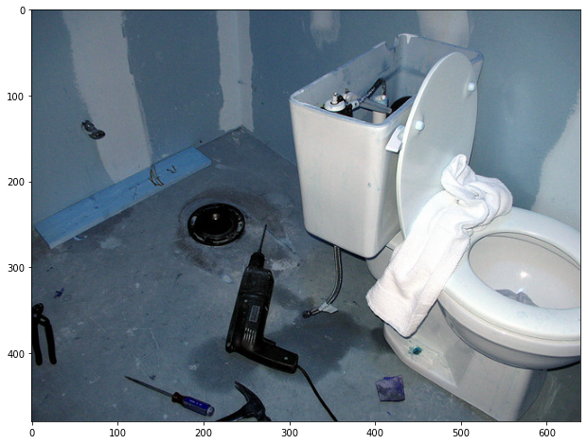

('What are the tools in the picture?',)

8

1

300

(1, 8, 300)

('drill, hammer, and screwdriver',)

6

('drill, hammer, and screwdriver',)

1

300

(1, 6, 300)

0

1

2

3

4

5

6

7

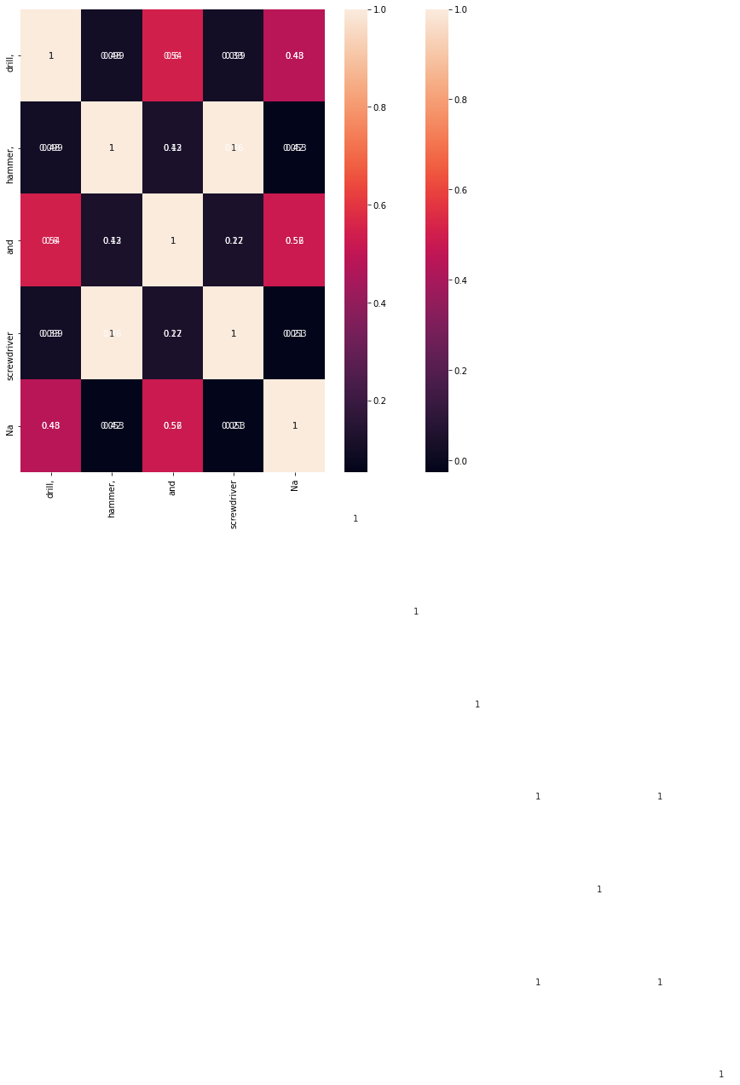

['124039', '359569', '355660', '37339', '105670', '4936', '500826', '547903', '506803', '505530', '81251', '67956', '209904', '73702', '424668', '115912', '475330', '104494', '207634', '475248', '41128', '37322', '112581', '127984', '69805', '24601', '226111', '179322', '426453', '497514']

115912

(399, 640, 3)

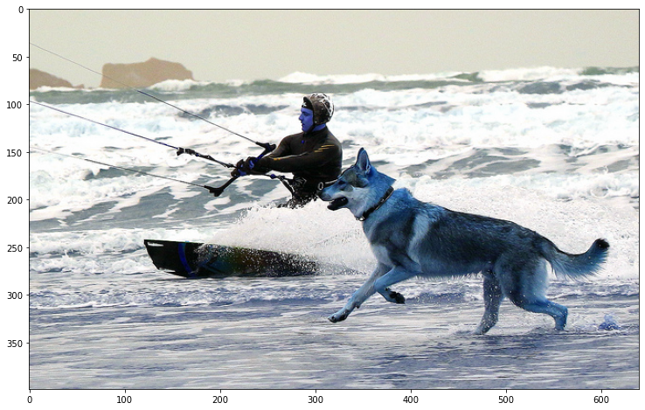

('Why is the dog running?',)

6

1

300

(1, 6, 300)

('to run beside his master',)

5

('playing in the water',)

1

300

(1, 5, 300)

0

1

2

3

4

5

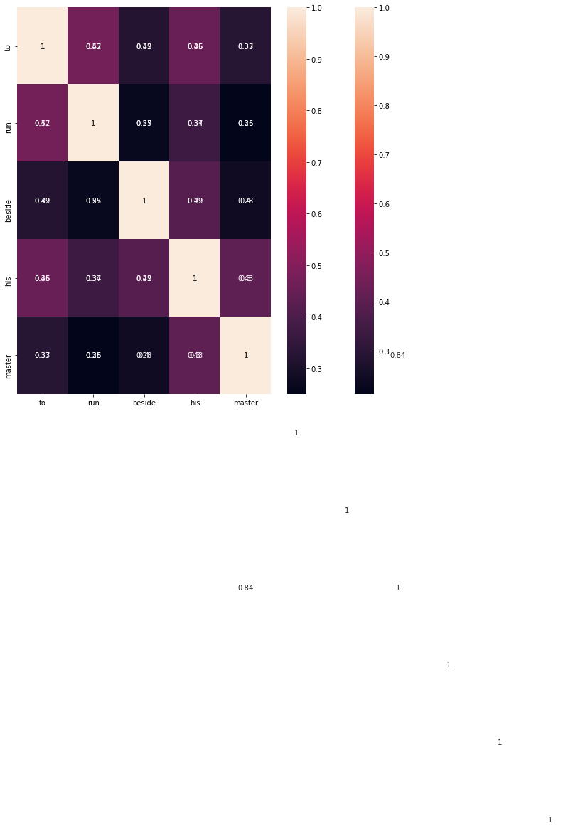

['124039', '359569', '355660', '37339', '105670', '4936', '500826', '547903', '506803', '505530', '81251', '67956', '209904', '73702', '424668', '115912', '475330', '104494', '207634', '475248', '41128', '37322', '112581', '127984', '69805', '24601', '226111', '179322', '426453', '497514']

475330

(333, 500, 3)

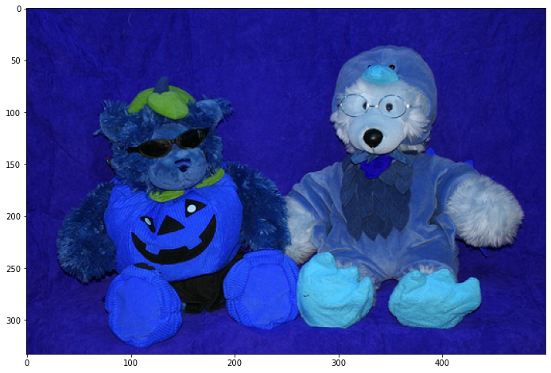

("What holidays do the bear's costumes represent?",)

9

1

300

(1, 9, 300)

('halloween and thanksgiving',)

3

('halloween and thanksgiving',)

1

300

(1, 3, 300)

0

1

2

3

4

5

6

7

8

['124039', '359569', '355660', '37339', '105670', '4936', '500826', '547903', '506803', '505530', '81251', '67956', '209904', '73702', '424668', '115912', '475330', '104494', '207634', '475248', '41128', '37322', '112581', '127984', '69805', '24601', '226111', '179322', '426453', '497514']

104494

(459, 640, 3)

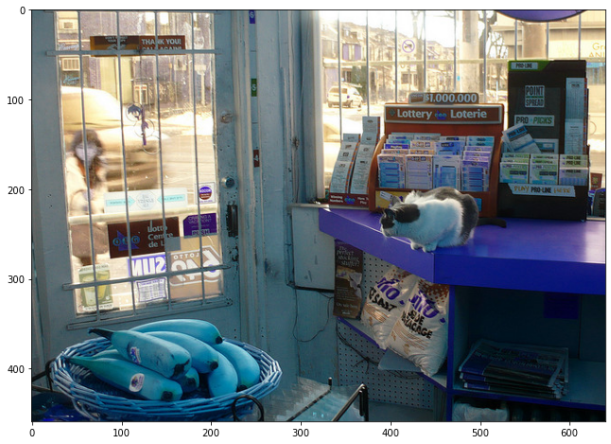

('Why is the cat crouching?',)

6

1

300

(1, 6, 300)

('to see better through window',)

5

('getting down from the table ',)

1

300

(1, 5, 300)

0

1

2

3

4

5

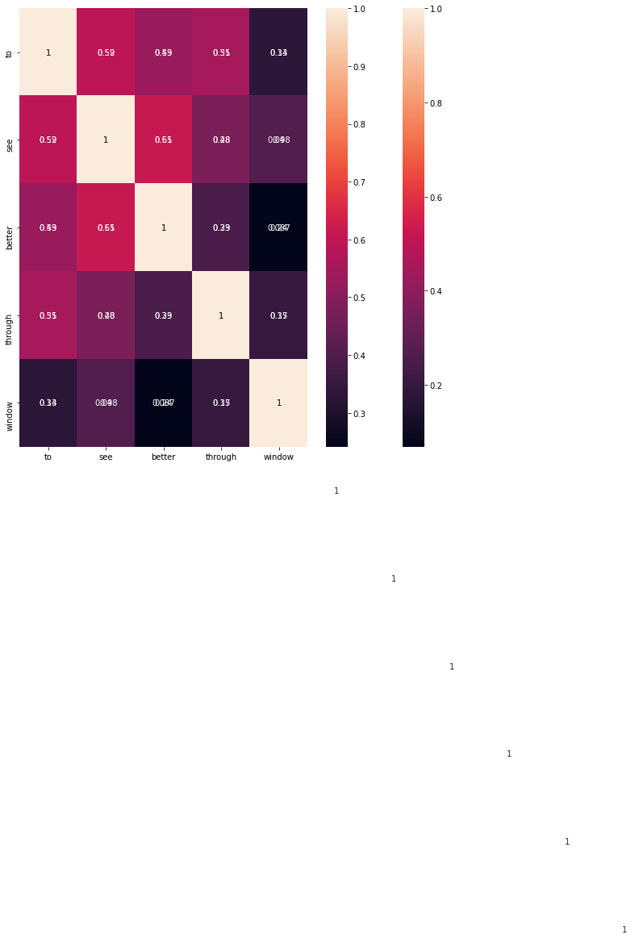

['124039', '359569', '355660', '37339', '105670', '4936', '500826', '547903', '506803', '505530', '81251', '67956', '209904', '73702', '424668', '115912', '475330', '104494', '207634', '475248', '41128', '37322', '112581', '127984', '69805', '24601', '226111', '179322', '426453', '497514']

207634

(640, 480, 3)

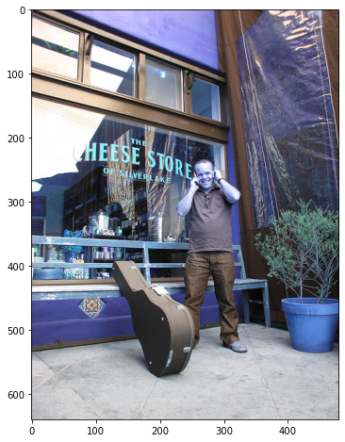

('What is the name of the store?',)

8

1

300

(1, 8, 300)

('cheese store of silver lake',)

5

('cheese store of silver lake',)

1

300

(1, 5, 300)

0

1

2

3

4

5

6

7

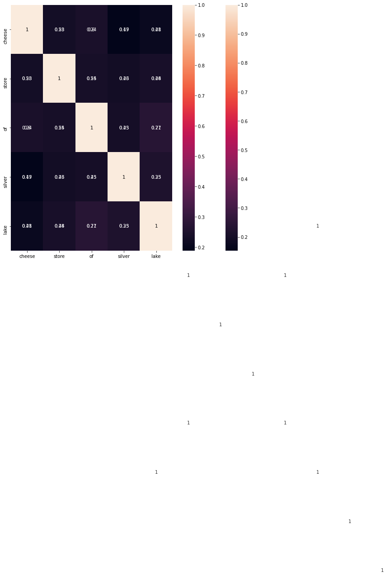

['124039', '359569', '355660', '37339', '105670', '4936', '500826', '547903', '506803', '505530', '81251', '67956', '209904', '73702', '424668', '115912', '475330', '104494', '207634', '475248', '41128', '37322', '112581', '127984', '69805', '24601', '226111', '179322', '426453', '497514']

475248

(480, 640, 3)

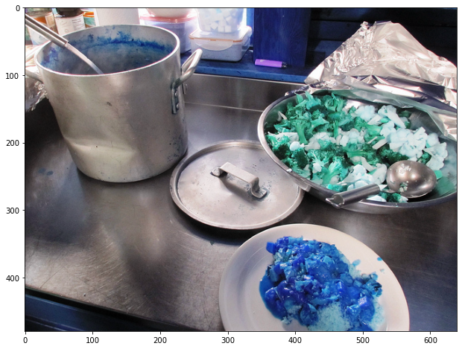

('What kind of vegetables are in the bowl on the right?',)

12

1

300

(1, 12, 300)

('broccoli and cauliflower',)

3

('broccoli and cauliflower',)

1

300

(1, 3, 300)

0

1

2

3

4

5

6

7

8

9

10

11



['124039', '359569', '355660', '37339', '105670', '4936', '500826', '547903', '506803', '505530', '81251', '67956', '209904', '73702', '424668', '115912', '475330', '104494', '207634', '475248', '41128', '37322', '112581', '127984', '69805', '24601', '226111', '179322', '426453', '497514']

41128

37322

112581

(480, 640, 3)

('Why the celebration?',)

4

1

300

(1, 4, 300)

('world series champions',)

3

('playing in the ground',)

1

300

(1, 3, 300)

0

1

2

3

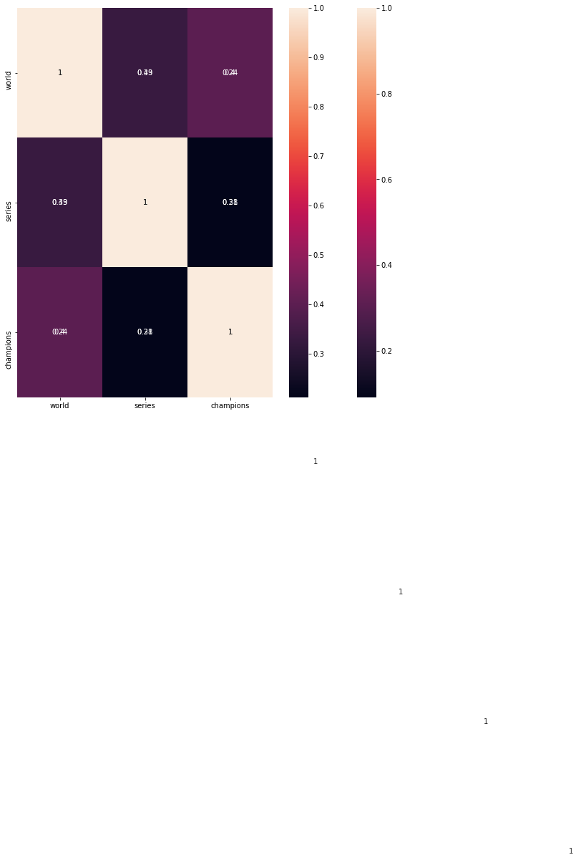

['124039', '359569', '355660', '37339', '105670', '4936', '500826', '547903', '506803', '505530', '81251', '67956', '209904', '73702', '424668', '115912', '475330', '104494', '207634', '475248', '41128', '37322', '112581', '127984', '69805', '24601', '226111', '179322', '426453', '497514']

('What does the sign say?',)

6

1

300

(1, 6, 300)

('sidewalk closed ahead cross here',)

5

('sidewalk closed ahead cross here')

1

300

(1, 5, 300)

0

1

2

3

4

5

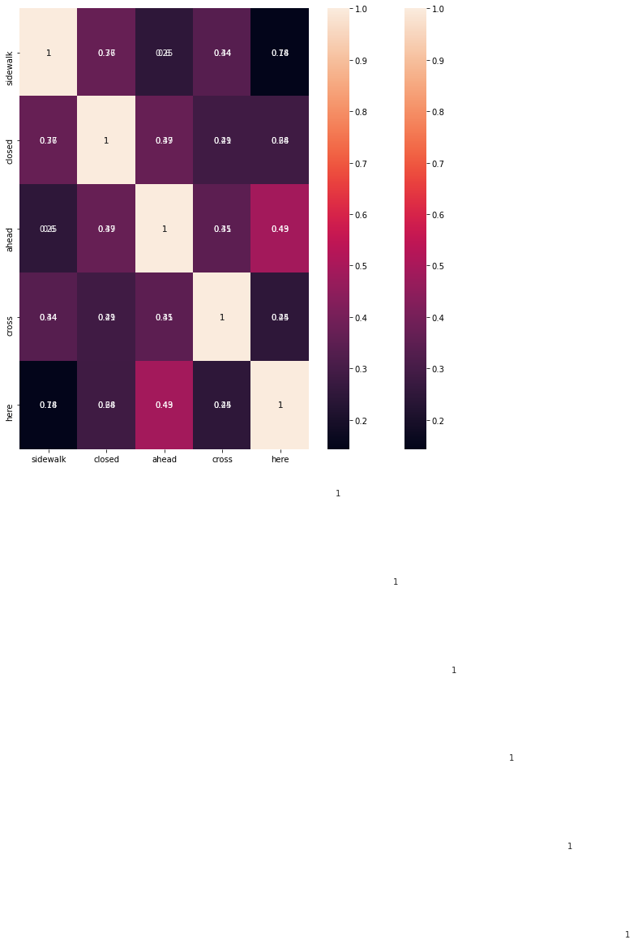

['124039', '359569', '355660', '37339', '105670', '4936', '500826', '547903', '506803', '505530', '81251', '67956', '209904', '73702', '424668', '115912', '475330', '104494', '207634', '475248', '41128', '37322', '112581', '127984', '69805', '24601', '226111', '179322', '426453', '497514']

41128

37322

112581

(480, 640, 3)

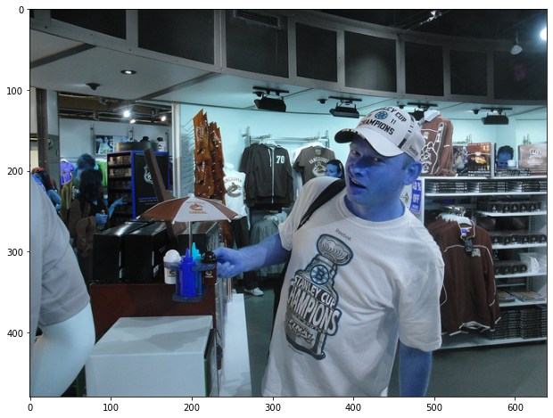

("What does the man's shirt read?",)

8

1

300

(1, 8, 300)

('stanley cup champions',)

3

('stanley cup champions',)

1

300

(1, 3, 300)

0

1

2

3

4

5

6

7



['124039', '359569', '355660', '37339', '105670', '4936', '500826', '547903', '506803', '505530', '81251', '67956', '209904', '73702', '424668', '115912', '475330', '104494', '207634', '475248', '41128', '37322', '112581', '127984', '69805', '24601', '226111', '179322', '426453', '497514']

127984

(640, 480, 3)

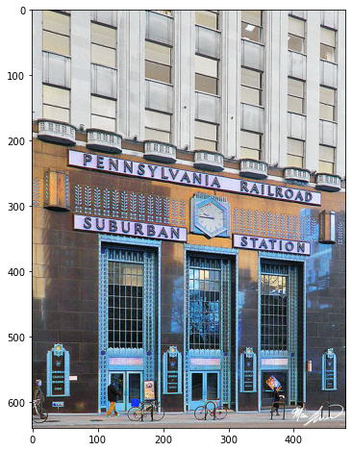

('What is the name of the station?',)

8

1

300

(1, 8, 300)

('pennsylvania railroad suburban station',)

4

('pennsylvania railroad suburban station',)

1

300

(1, 4, 300)

0

1

2

3

4

5

6

7

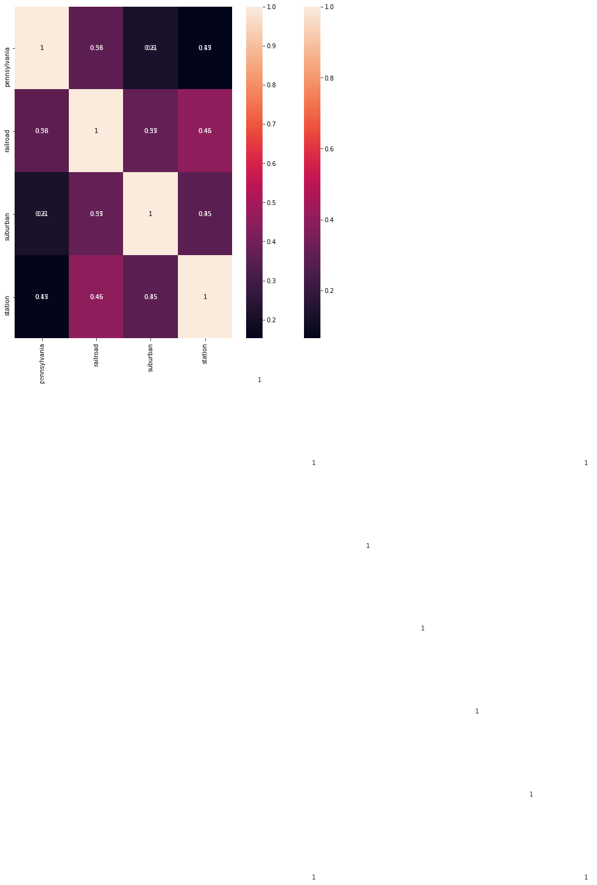

['124039', '359569', '355660', '37339', '105670', '4936', '500826', '547903', '506803', '505530', '81251', '67956', '209904', '73702', '424668', '115912', '475330', '104494', '207634', '475248', '41128', '37322', '112581', '127984', '69805', '24601', '226111', '179322', '426453', '497514']

('Why does the bird appear to be so large?',)

10

1

300

(1, 10, 300)

('bird appears larger because it is closer to camera',)

9

('sitting near to the view',)

1

300

(1, 9, 300)

0

1

2

3

4

5

6

7

8

9

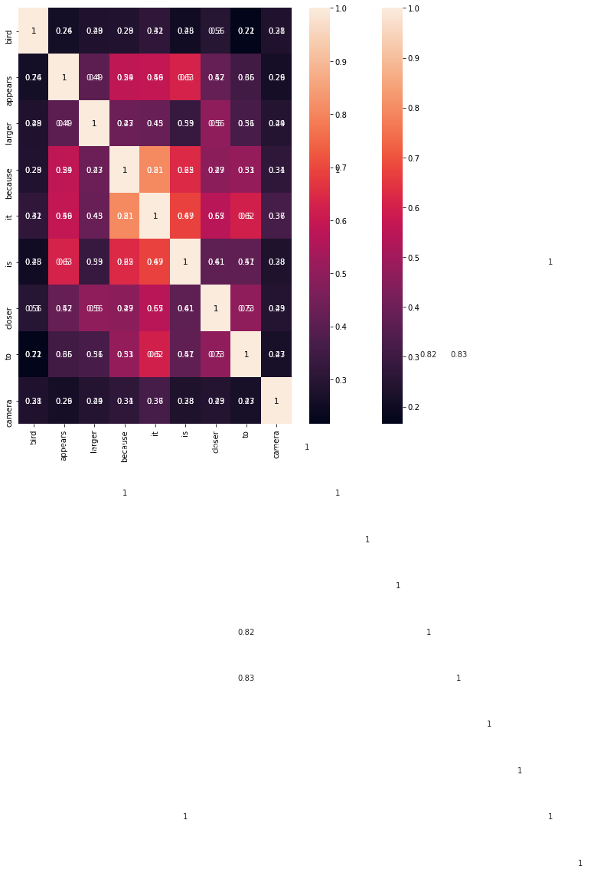

['124039', '359569', '355660', '37339', '105670', '4936', '500826', '547903', '506803', '505530', '81251', '67956', '209904', '73702', '424668', '115912', '475330', '104494', '207634', '475248', '41128', '37322', '112581', '127984', '69805', '24601', '226111', '179322', '426453', '497514']

('Who has on red?',)

5

1

300

(1, 5, 300)

('man at back right and man far left',)

8

('others are sitting',)

1

300

(1, 8, 300)

0

1

2

3

4

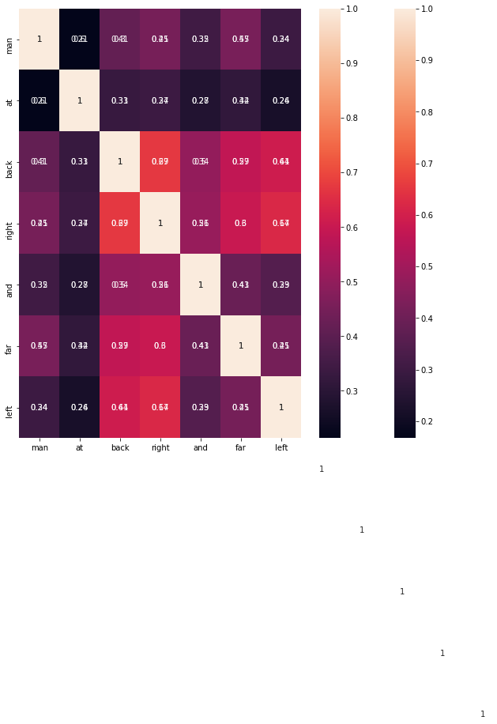

['124039', '359569', '355660', '37339', '105670', '4936', '500826', '547903', '506803', '505530', '81251', '67956', '209904', '73702', '424668', '115912', '475330', '104494', '207634', '475248', '41128', '37322', '112581', '127984', '69805', '24601', '226111', '179322', '426453', '497514']

226111

(640, 480, 3)

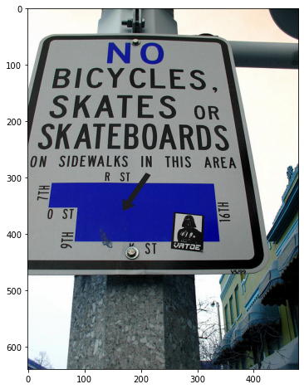

('What is not allowed according to the sign?',)

9

1

300

(1, 9, 300)

('bicycles, skates, skateboards',)

5

('bicycles, skates, skateboards',)

1

300

(1, 5, 300)

0

1

2

3

4

5

6

7

8



['124039', '359569', '355660', '37339', '105670', '4936', '500826', '547903', '506803', '505530', '81251', '67956', '209904', '73702', '424668', '115912', '475330', '104494', '207634', '475248', '41128', '37322', '112581', '127984', '69805', '24601', '226111', '179322', '426453', '497514']

179322

(480, 640, 3)

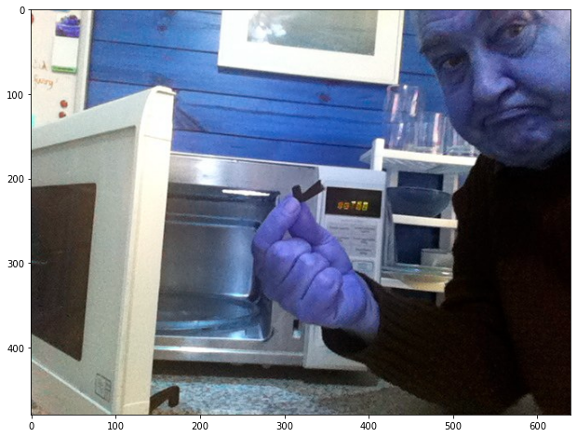

('What does the man have on his hand?',)

9

1

300

(1, 9, 300)

('broken piece to microwave',)

4

('broken piece to microwave',)

1

300

(1, 4, 300)

0

1

2

3

4

5

6

7

8



['124039', '359569', '355660', '37339', '105670', '4936', '500826', '547903', '506803', '505530', '81251', '67956', '209904', '73702', '424668', '115912', '475330', '104494', '207634', '475248', '41128', '37322', '112581', '127984', '69805', '24601', '226111', '179322', '426453', '497514']

426453

(427, 640, 3)

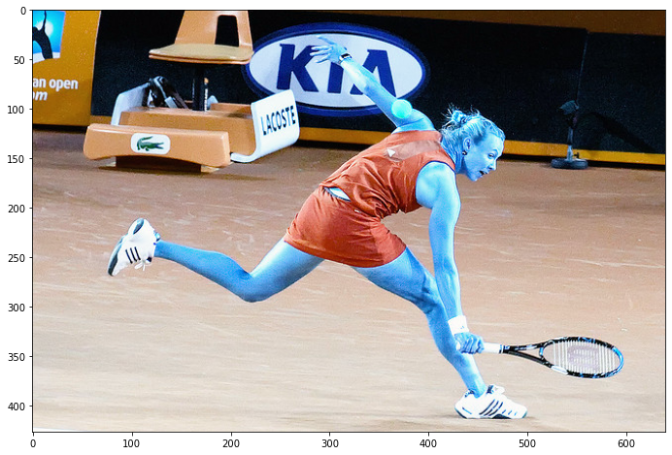

('Why does the woman have a tennis ball on her shoulder?',)

12

1

300

(1, 12, 300)

('she missed hitting it',)

4

('running other side',)

1

300

(1, 4, 300)

0

1

2

3

4

5

6

7

8

9

10

11



['124039', '359569', '355660', '37339', '105670', '4936', '500826', '547903', '506803', '505530', '81251', '67956', '209904', '73702', '424668', '115912', '475330', '104494', '207634', '475248', '41128', '37322', '112581', '127984', '69805', '24601', '226111', '179322', '426453', '497514']

497514

(640, 480, 3)

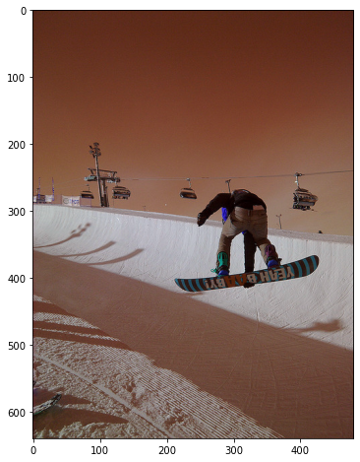

('What is the function of the cars on the cable?',)

11

1

300

(1, 11, 300)

('to lift people up slope',)

5

('to lift people up slope',)

1

300

(1, 5, 300)

0

1

2

3

4

5

6

7

8

9

10

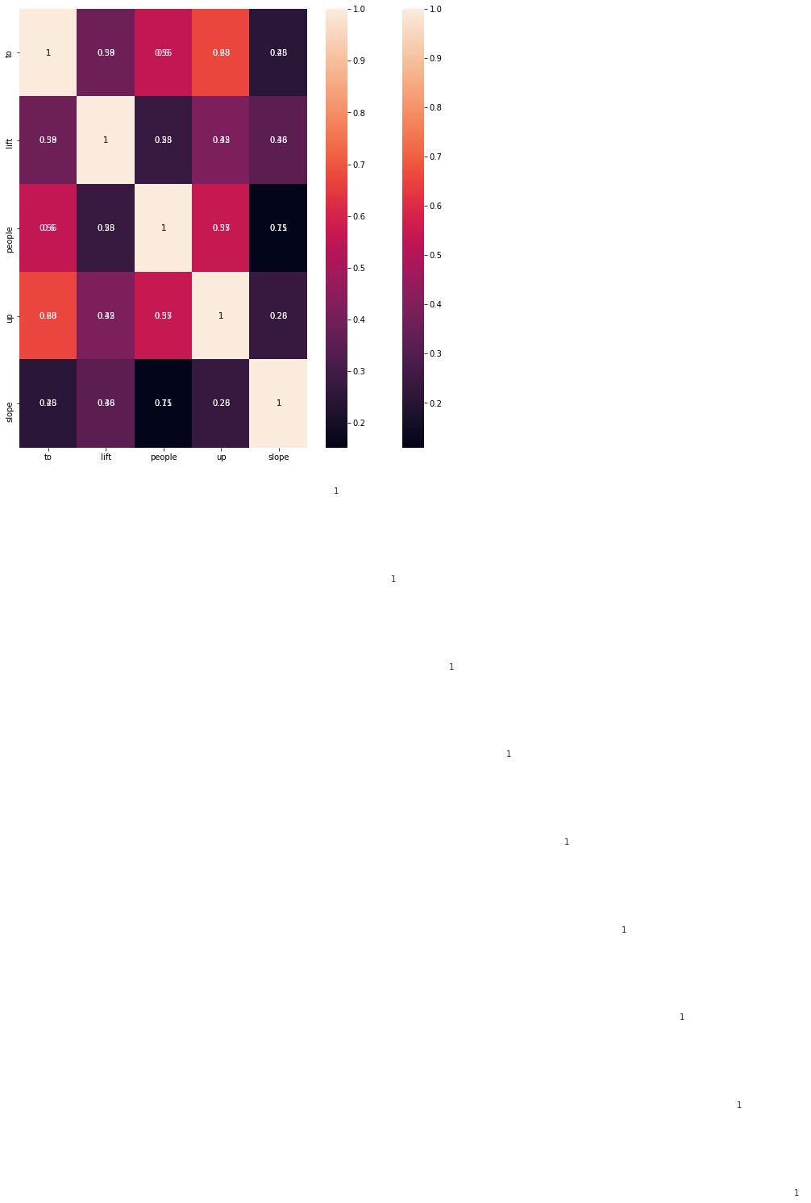



NOTE: Verify both the things both are same the one which is in the top of this and the one you see both heat maps are same.

REFERENCES:

* <https://www.analyticsvidhya.com/blog/2020/03/spacy-tutorial-learn-natural-language-processing/>
* <https://engagedscholarship.csuohio.edu/cgi/viewcontent.cgi?article=2192&context=etdarchive>
* <https://towardsdatascience.com/deep-learning-and-visual-question-answering-c8c8093941bc>
* <https://keras.io/api/>
* <https://www.geeksforgeeks.org/python-opencv-cv2-imshow-method/>
* <https://towardsdatascience.com/a-comparison-of-dnn-cnn-and-lstm-using-tf-keras-2191f8c77bbe>
* <https://medium.com/@sprhlabs/understanding-deep-learning-dnn-rnn-lstm-cnn-and-r-cnn-6602ed94dbff>